# 

**ELECTROMAGNETIC INTERFERENCE (EMI ) AND ELECTROMAGNETIC COMPATABILITY TESTING**

# INTERNSHIP PROJECT REPORT

# Submitted by

# Biancaa.R

# III year

# ECE DEPT

# unnamed.jpgSSN COLLEGE OF ENGINEERING

**INTERNED IN CVRDE DRDO -EMI / EMC**



**From 16.7.24 to 17.8.24,under the guidance of**

**Mr. Phanikrishna P sir, Scientist ‘E’**

**ACKNOWLEDGEMENT:**

I wish to express my profound and heartfelt gratitude to the esteemed organization, CVRDE DRDO (Combat Vehicles Research and Development Establishment, Defence Research and Development Organisation), for bestowing upon me the exceptional opportunity to undertake this prestigious internship.

At the outset, I extend my deepest and most sincere thanks to the distinguished Head of Department, Dr. P. Vijayalakshmi, whose unwavering support and gracious encouragement have been instrumental in facilitating my participation in this invaluable internship. Her benevolent guidance has been the cornerstone upon which this report stands, and without her visionary leadership, this endeavor would have remained a distant aspiration.

I am profoundly indebted to PalaniKumar sir of the FV Department, whose expertise and unwavering support have been a constant source of inspiration throughout the course of this internship.

My heartfelt gratitude also extends to

P. Phani Krishna sir, Scientist 'E', and K. Gurusankar sir, TO 'A', whose exceptional mentorship and guidance have been invaluable. Additionally, I would like to convey my genuine appreciation to Sandeep Kumar sir, STA 'B', Jayapriya ma,am, JRF, and Raghav sir of the Vehicle Communication Division – EMI/EMC, for their steadfast support, encouragement, and invaluable insights, which have significantly enriched my experience during this internship.

My heartfelt thanks are also extended to the remarkable team with whom I had the privilege of collaborating. Their camaraderie, dedication, and shared vision have made this journey not only enlightening but also profoundly rewarding.

In essence, this journey has been illuminated by the collective efforts, wisdom, and unwavering support of these esteemed individuals, without whom this endeavor would not have reached its successful fruition. Their contributions have not only shaped this internship but have also left an indelible mark on my professional and personal growth, for which I am eternally grateful.

**ABSTRACT**

This report provides an in-depth examination of Electromagnetic Compatibility (EMC) and Electromagnetic Interference (EMI) testing within the Defence Research and Development Organization (DRDO). The primary objectives of EMC/EMI testing include ensuring the operational integrity, compliance with stringent standards, safety, and reliability of defence systems. To achieve these goals, DRDO employs a multifaceted approach, leveraging advanced facilities such as anechoic chambers, reverberation chambers, open-area test sites, and shielded enclosures.

The testing process is thorough and systematic, beginning with the design review phase and extending through to post-compliance monitoring. This rigorous process ensures adherence to standards such as MIL-STD-461, which is pivotal for maintaining high performance and reliability. The report details the comprehensive testing procedures for emissions and susceptibility, including specialized tests such as RE102 (Radiated Emissions), RS103 (Radiated Susceptibility), CE102 (Conducted Emissions).

Furthermore, the report delves into essential topics such as field calibration, the use of spectrum analysers, ambient measurement techniques, and attenuation measurement. It also covers the control of Vector Network Analysers (VNAs) through Standard Commands for Programmable Instruments (SCPI), the conversion of dBm to dBµV, the interpretation of S-parameters, and the analysis of antenna radiation patterns. Additionally, the report includes discussions on Ultra-Sensitive Detection Systems (USDS) and provides experimental images of tests conducted at the Combat Vehicles Research and Development Establishment (CVRDE).

This comprehensive report underscores DRDO's unwavering commitment to ensuring the reliable performance of its systems within complex electromagnetic environments. It highlights the organization's dedication to maintaining the highest standards of operational excellence and safety in defence technology.

**Defence Research and Development Organisation (DRDO)**

The Defence Research and Development Organisation (DRDO) is the research and development (R&D) wing of India's Ministry of Defence. DRDO's mission is to develop and produce state-of- the-art weapon systems, defense equipment, and sensors for the Indian Armed Forces. DRDO also aims to achieve self-reliance in critical defense technologies and systems, and to equip the armed forces with cutting-edge defense technologies.DRDO has a network of 52 laboratories that work in various fields, including aeronautics, armaments, electronics, land combat engineering, life sciences, materials, missiles, and naval systems. The organization employs around 5,000 scientists and 25,000 other scientific, technical, and supporting personnel. DRDO has achieved many successes since its inception, including developing major systems and critical technologies such as aircraft avionics, UAVs, small arms, artillery systems, EW systems, tanks and armored vehicles, sonar systems, command and control systems, and missile systems

|  |  |  |  |  |
| --- | --- | --- | --- | --- |
| **CONTENTS** | | | | |
|  | **S.NO** | **TITLE** | **PAGE NO** |  |
| 1. | Introduction  1.a common applications of EM1 /EMC  1.a.1 medical devices  1.a.2 Military/Aerospace devices  1.a.3 Consumer goods  1.b EMC testing routines  1.c Notable hazards due to EMC failure  1.c.1 Talking ecg machines  1.c.2 Ambulance heart monitoring system  1.c.3 Runaway wheel chair  1.c.4 Antilock braking system failure  1.c.5 Mercedes Benz case | 9 |
| 2. | Standards of EMI/ EMC  2.1 Military : general military standard MIL STD 461 F  2.2 Difference between commercial and military standard | 11 |
| 3. | Environment for EMI/ EMC  3.1 Qualities of EMI EMC chamber  3.2 Anechoic chamber  3.2.1 Types of anechoic chamber  3.2.2 construction of anechoic chamber  3.2.3 Materials used in anechoic chamber construction  3.2.4 Applications of anechoic chamber  3.2.5 EMI due to slots and apertures | 12 |
|
|

|  |  |  |
| --- | --- | --- |
| 4. | Components used in EMI EMC testing  4.1 Antenna   * 4.1.1 Antenna beam width * 4.1.2 How beamwidth is measured   4.1.2.1 accounting for different antennas   * 4.1.3 Gain * 4.1.3.1 Antenna measurement * 4.1.4 Antenna impedance * 4.1.5 Universal spectral dipole source * 4.1.6 effect of metal used for antenna design * 4.1.7 Efficiency of antennas * 4.1.8 Directivity * 4.1.9 Types of antenna   4.2 Vector network analyzer   * 4.2.1 VNA vs spectrum analyzer * 4.2.2 Typical vna measurements * 4.2.3 Swept frequency measurement * 4.2.4 Need of a VNA * 4.2.5 Basic VNA operations * 4.2.6 key specifications * 4.2.7 understanding s parameters * 4.2.8 SCPI commands in vna * 4.2.9 examples developed * 4.3 Emi receiver * 4.3.1 Resolution bandwidth * 4.3.2 Phase noise * 4.3.3 Conversion related to power in dB | 19 |

|  |  |  |
| --- | --- | --- |
| 5. | Insertion Loss of VNA using direction coupler  5.1 Directional Coupler  5.2 How to Measure VSWR Using a Directional Coupler  5.3 VSWR  5.4 SMITH CHART  5.4.1 Components of Smith Chart  5.4.1.1 Constant R Circles  5.4.1.2 Constant X Circles  5.4.1.3 Advantages of Smith Chart  5.4.1.4 Applications of Smith Charts | 42 |

|  |  |  |
| --- | --- | --- |
| 6. | * **MIL-STD-461 CE 102** * 6.1 Purpose * 6.2 Test Equipment   + Fig 6.2.1 A.B .Rohde & SchwarzESRP3 EMI Test Receiver per CISPR 16-1-1 * 6.3 Test Procedure * 6.4 Test Setup   + A. Calibration | 48 |
| 7. | RADIATED EMISSION-RE102   * 7.1 Purpose * 7.2 Requirement * 7.3 Test Setup * 7.4 Test equipment * 7.5 Testing Procedures | 51 |
| 8. | Radiated susceptibility-RS103   * 8.1 Purpose * 8.2 Requirement * 8.3 Test procedure * 8.4 Test setup | 53 |

|  |  |  |
| --- | --- | --- |
| 9 | conclusion | 55 |
| 10 | Refferences | 55 |

* **INTRODUCTION**

**Electromagnetic Interference (EMI)** and **Electromagnetic Compatibility (EMC)** are fundamental concepts in the design and development of electronic systems. They are intricately linked, yet distinct, disciplines that are crucial for ensuring the reliable operation of electronic devices in their intended environments.

**Electromagnetic Interference (EMI)**

EMI refers to the unwanted electromagnetic energy that can disrupt the operation of electronic devices, electrical systems, or radio frequency systems. This interference can originate from various sources, including:

1. **Conducted EMI:** Transmitted through power or signal cables.
2. **Radiated EMI:** Propagated through the air as electromagnetic waves.

Sources of EMI can be man-made (e.g., power supplies, motors, digital circuits) or natural (e.g., lightning, solar flares).

**Electromagnetic Compatibility (EMC)**

EMC is the ability of an electronic device or system to function satisfactorily in its electromagnetic environment without causing unacceptable electromagnetic disturbance to anything else. It encompasses both emission and immunity aspects:

1. **Immunity testing** - measures how a device will react when exposed to electromagnetic noise and other disturbances. The purpose of these tests is to gain a reasonable assurance that the device will operate as intended when used within its expected operating environment. The device should be able to withstand electromagnetic disturbances without malfunctioning. EMC standards and regulations have been established to ensure the compatibility of electronic devices and systems, promoting a harmonious electromagnetic environment.
2. **Emissions testing** - measures the amount of electromagnetic noise generated by a device during normal operation. The purpose of these tests is to ensure that any emission from the device are below the relevant limits defined for that type of device. ie. The device should not generate excessive electromagnetic energy that interferes with other devices.[5]

**1.a COMMON APPLICATIONS OF EMI/ EMC:**

**1.a.1 Medical Devices:**

EMC testing is critical for managing risk in medical device manufacturing. Devices must be able to work together in close environments without interference or noise compromising performance. The FDA requires that all medical devices undergo EMC testing per the appropriate FDA Reviewer Guidance document or the European IEC 60601-1-2 standards. In the EU, all medical devices must have CE marking, which requires both immunity and emissions testing per IEC 60601-1-2.

**1.a.2 Military/Aerospace Devices:**

MIL-STD-461 outlines EMC testing requirements for military equipment, including electromagnetic susceptibility and emissions testing. MIL-STD-461 contains relatively stringent electromagnetic compatibility requirements. Devices which are compliant with MIL-STD-461 are typically well-positioned to meet FCC, DO-160 and other standards for avionics equipment, consumer goods and other products.

**1.a.3 Consumer Goods:**

Consumer goods such as microwave ovens, cellular phones, laptops and satellite TV dishes all must undergo EMC/EMI testing to ensure they do not cause harmful interference and accept interference without causing undesired operation in real-world conditions. For more information about EMC/EMI testing for different devices, contact Com-Power Corporation directly.

**1.b EMC Testing Routines:**

**(What are the hazardous conditions being simulated?)**

A specific EMC testing routine is determined by the nature of the device being tested, its intended application and and the regulatory requirements governing its use. Electromagnetic phenomena that may be simulated through EMC testing include:

1. Magnetic fields, such as those radiating from electrical wires
2. Voltage drops due to a brownout or other power interruption
3. Electromagnetic surges due to a lightning strike
4. Conducted and radiated electromagnetic noise
5. Electrostatic discharges associated with static electricity
6. Fast transients caused by electrical switches, motors and relays, fluorescent lamp ballasts, for example.

A wide range of equipment is used to simulate the above conditions and determine the ability of a device under test to recover from them. A typical EMC testing lab may utilize [surge generators](https://www.com-power.com/products/surge-generators), [power amplifiers](https://www.com-power.com/products/power-amplifiers), [spectrum analyzers](https://www.com-power.com/products/spectrum-analyzers) and more.

**1.c NOTABLE HAZARDS DUE TO EMC FAILURE:**

**(cite:** **https://ntrs.nasa.gov/api/citations/19960009442/downloads/19960009442.pdf)**

**1.c.1 Talking EEG Machine**

This case involved EM1 that prevented proper testing of surgically implanted probes used in monitoring specific portions of a patient's brain activity. With probes in direct brain contact, the potential between any two points is measured on an EEG machine. The EEG provides critical feedback to the surgeon during surgery. This particular EM1 manifested itself on the analog plotting needles of the EEG machine as a modulated signal easily recognized as speech-hence a talking EEG machine! The EMI-caused noise was so severe that it completely,masked the EEG signals and made the machine alarmingly ineffectual during surgery. The signal was from a local AM radio station, and the noise during surgery was from common impedance coupling between the EEG machine and the operating table. Bonding the EEG with the operating table eliminated the EM1 and restored the critical brain monitoring function.

**1.c.2 Ambulance Heart MonitorAIefibrillator** Susceptibility of medical equipment to conducted or radiated emission is a concern. In this case, a 93-year-old heart attack victim was being taken to the hospital and the medical technician had attached a monitor/defibrillator to the patient. Because the machine shut down every time the technicians turned on the radio transmitter to request medical advice, the patient died. An investigation showed that the monitor/defibrillator was exposed to exceptionally high radiated emissions because the ambulance roof had been changed from metal to fiberglass and fitted with a long-range radio antenna. Reduced shielding combined with the strong radiated radio signal resulted in EM1 to the vital machine.*'

**1.c.3 Runaway Wheelchairs** Wheelchairs came under the scrutiny of the FDA (fig. 5) because of reported erratic, unintentional powered-wheelchair movements. These movements included sudden starts that caused wheelchairs to drive off curbs or piers when police, fire, or CB transmitters were activated near the chairs. Although no fatal injuries have been reported, FDA has ordered manufacturers of motorized wheelchairs to shield them from EM1 and to educate users on the potential EM1 hazards.2'

**1.c.4 Antilock Biaking System (ABS) Failure** :Early ABS systems on both aircraft and automobiles were susceptible to EMI. Accidents 1 occurred when the brakes functioned improperly because EM1 disrupted the ABS control system. 10 For aircraft, the initial solution was to provide a manual switch to lock out the ABS function when it was inoperable due to EM1 and to use the normal braking system. Later, the solution was to qualify prior to flight the ABS system based on the expected EME. For automobile systems, the solution was to ensure, if EM1 occurs, that the ABS system degrade gracefully to normal braking-ssentially an automatic version of the aircraft manual switch. Eventually, automobile ABS was qualified by EM1 testing prior to procurement.8 ’ Cellular Phone l Laptop Computer Radio Electronic Game CD Player Tape Player AM-FM Recorder AM-FM Walkman Dictaphone Heart Monitor Television

**1.c.5 Mercedes-Benz Case Navigation Aids** During the early years of ABS’s, Mercedes-Benz automobiles equipped with ABS had severe braking problems along a certain stretch of the German autobahn. The brakes where affected by a near-by radio transmitter as drivers applied them on the curved section of highway. The nearterm solution was to erect a mesh screen along the roadway to

attenuate the EMI. This enabled the brakes to function properly when drivers applied them.

**2.STANDARDS OF EMI EMC TESTING:**

Table 2.1

|  |  |  |
| --- | --- | --- |
| **Application** | **Common EMC Standard(s)** | **Significance** |
| Medical | IEC 60601-1-2 | This standard regulates the safety and performance of medical equipment and systems under electromagnetic environments. |
| Automotive | SAE, ISO7637, IEC CISPR-25, ISO1145-1, ISO1145-2 | Addresses test procedures, measuring techniques, and the allowable limits of electromagnetic disturbances affecting electrical and electronic components in the automotive sector. |
| Military | MIL-STD-461, DEF STAN 59/411, MIL-STD-704, MIL-STD-1275, MIL-STD-1399 | Regulates the electromagnetic emissions and susceptibility of the systems used in military applications. |
| Industrial | FCC Part 15 class A, EN 61000-6-4 (generic), EN 61000-6-2(generic) | A general set of EMC standards for regulating the intentional, unintentional, or incidental radiations for devices used in commercial, industrial, or business environments. |
| Commercial | FCC Part 15 class B, EN 61000-6-3 (generic), EN 61000-6-1(generic) | Devises the immunity requirements for electrical and electronic equipment used in commercial, public, light-industrial, or residential locations. |
| Switchgear and control | EN/IEC 60947-1 | Regulates low-voltage switch gears and control gears with working voltages within 1500 V DC and 1000 V AC. |
| Power station and substation | IEC TS 61000-6-5 | Sets the immunity levels for the equipment utilized in the generation, transmission, and distribution of electricity. |
| Process control and measurement | EN/IEC 61326-1 | Specifies the immunity and emissions levels of electrical equipment or devices with a working potential less than 1000 Vac and 1500 V DC. |

# 2.1 MILITARY : General military standard : MIL STD 461F:

This standard establishes interface and associated verification requirements for the control of the electromagnetic interference (EMI) emission and susceptibility characteristics of electronic, electrical, and electromechanical equipment and subsystems designed or procured for use by activities and agencies of the Department of Defence (DoD)

Emission and susceptibility designations. The emissions and susceptibility and associated test procedure requirements in this standard are designated in accordance with an alphanumeric coding system. Each requirement is identified by a two-letter combination followed by a three- digit number. The number is for reference purposes only. The meaning of the individual letters is as follows, (C = Conducted, R = Radiated, E = Emission, S = Susceptibility)

* 1. Conducted emissions requirements are designated by "CE"
  2. Radiated emissions requirements are designated by "RE"
  3. Conducted susceptibility requirements are designated by "CS"
  4. Radiated susceptibility requirements are designated by "RS"
  + **DIFFERENCE BETWEEN THE COMMERCIAL AND MILITARY STANDARDS:**

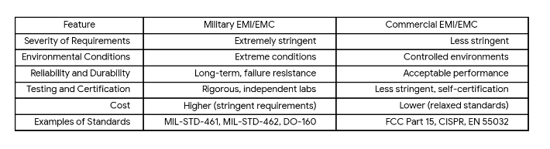Table 2.1.1

**3.ENVIRONMENT FOR THE EMI EMC TESTING:**

An EMI/EMC (Electromagnetic Interference/Electromagnetic Compatibility) chamber is a specialized facility designed to test and measure the electromagnetic emissions and susceptibility of electronic and electrical devices. The chamber's design and construction incorporate several key qualities that ensure accurate, repeatable, and reliable testing. Here are the essential qualities of an EMI/EMC chamber:

**3.1 QUALITIES OF EMI EMC CHAMBER:**

• **Electromagnetic Shielding**

**Faraday Cage Construction:** The chamber is housed within a Faraday cage to block external electromagnetic fields, preventing RF interference during tests.

**High Shielding Effectiveness:** Advanced materials and construction provide superior shielding, measured in decibels (dB), ensuring effective isolation from external electromagnetic environments.

• **Low Reflectivity**

* **RF Absorber Materials:** The chamber's interior is lined with RF absorbers, like carbon-loaded foam or ferrite tiles, minimizing internal electromagnetic wave reflections.
* **Minimized Internal Reflections:** Designed to reduce internal reflections, ensuring that only the DUT's emissions are detected.

• **Controlled Environment**

* **Temperature and Humidity Control:** Environmental factors such as temperature and humidity are regulated to ensure consistent and accurate test results.
* **Vibration Isolation:** The chamber is built on an isolated foundation to minimize the impact of external vibrations on sensitive measurements.

• **Precision Measurement Capabilities**

* **Accurate Calibration:** Equipped with calibrated measurement tools, the chamber ensures precise and reliable test results.
* **Broad Frequency Range:** Capable of testing across a wide frequency range, from a few kHz to several GHz, meeting standards like MIL-STD-461, CISPR, and FCC regulations.

• **Versatility**

* **Multi-Purpose Testing:** Supports various tests, including radiated/conducted emissions and susceptibility, providing comprehensive electromagnetic performance assessments.
* **Customizable Configuration:** Configurable with different antennas and equipment to meet industry-specific testing needs.

• **Compliance with Standards**

* **Adherence to International Standards:** The chamber complies with global standards such as MIL-STD-461, CISPR 16, and IEC 61000-4 series, ensuring industry and regulatory compliance.
* **Certification and Validation:** Regular certification and validation by recognized authorities ensure consistent performance.

• **Safety Features**

* **Personnel Protection:** Safety features like interlocks, warning systems, and emergency shut-offs protect personnel from high RF energy exposure.
* **Proper Grounding:** Grounding systems prevent electrical hazards and maintain measurement integrity.

• **Ease of Use**

* **User-Friendly Interface:** Modern software interfaces simplify test setup, execution, and analysis.
* **Automated Testing Capabilities:** Automation enhances test repeatability and reduces human error, ensuring consistent results.

• **Flexibility in Size and Design**

* **Scalable Dimensions:** Available in various sizes, from small benchtop models to large walk-in chambers, accommodating diverse testing needs.
* **Modular Design:** Modular construction allows for future expansion or reconfiguration to meet evolving testing standards.

• **Reliability and Durability**

* **Long-Term Stability:** Built with durable materials for long-term stability and consistent performance over years of use.
* **Resilience to Wear and Tear:** High-quality construction ensures the chamber withstands frequent use without performance degradation.

# ANECHOIC CHAMBER

An-echoic meaning “non-reflective” or “without echoes” is a room designed to stop reflections or echoes of either sound or electromagnetic waves. They are also often isolated from energy entering from their surroundings. This combination means that a person or detector exclusively hears direct sounds (no reflected sounds), in effect simulating being outside in a free field.

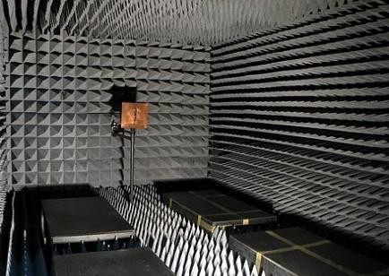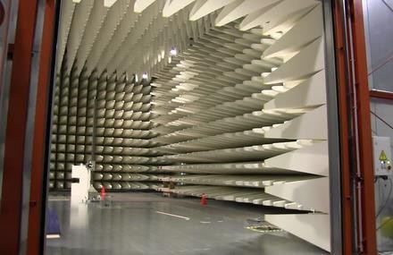

**Fig 3.2.1 Fully Anechoic Chamber: Fig 3.3.2 Semi Anechoic chamber:**

An anechoic chamber is a shielded room designed to suppress sound and/or electromagnetic energy. It is designed to suppress the electromagnetic wave energy of echoes such as reflected electromagnetic waves from the internal surfaces and to provide effective isolation from the acoustic or RF noise present in the external environment. Anechoic chambers are also used to accurately measure an antenna’s gain, efficiency, and radiation patterns. These antennas are vital components for communication of almost all devices ranging from satellites, military vehicles, aircrafts, mobile phones, etc. The chambers are also used to test radiations for medical devices such as X-ray, MRI, CT-scan machines, etc.

**3.2.1 Types of anechoic chamber:**

1.Acoustic anechoic chambers 2.RF anechoic chambers

# Construction:

In order to make the anechoic chambers free of reflection, the interior surfaces of the RF anechoic chamber are covered with radiation absorbent material (RAM). The most common absorber is made of carbon loaded foam shaped like a pyramid. Sharp tips on the absorbers help

to absorb RF waves without letting them from bouncing off. Due to its shape, the amount of RF that bounces off anechoic chamber walls is often 0.1% to 1% (-30 to -20 dB) of the original wave. The one in the EMI EMC testing facility was constructed by ETS Lindgren, an ESCO testing company.These anechoic chambers have a high-performance wall panel system that provides the low-noise environment required to test today’s low-noise products

# Materials used:

* + 1. Foam RF Absorber.
    2. EMC Chamber Filters.
    3. RF Shielded Doors.
    4. EMC Shielded Cameras.
    5. EUT Transient Monitors.
    6. Data Transmission.

# Shielding Enclosures:

To prevent interaction between the EUT and the outside environment, shielded enclosures will usually be required for testing. These enclosures prevent external environment signals from contaminating emission measurements and susceptibility test signals from interfering with electrical and electronic items in the vicinity of the test facility.

# Radio Frequency (RF) absorber material:

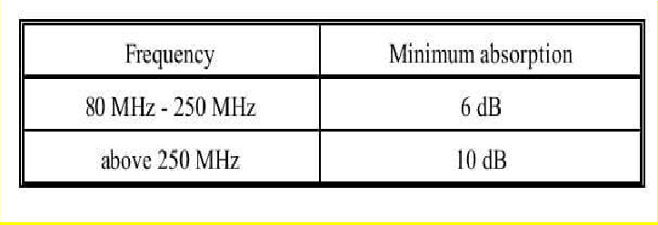RF absorber material (carbon impregnated foam pyramids, ferrite tiles, and so forth) shall be used when performing electric field radiated emissions or radiated susceptibility testing inside a shielded enclosure to reduce reflections of electromagnetic energy and to improve accuracy and repeatability. The RF absorber shall be placed above, behind, and on both sides of the EUT, and behind the radiating or receiving antenna as shown in the below figure. Minimum performance of the material shall be as specified in Table I. The manufacturer's certification of their RF absorber material (basic material only, not installed) is acceptable

**Faraday Cage**: The chamber is built inside a Faraday cage, which is a structure, made of conductive material (such as metal mesh or plates) that blocks external electromagnetic fields. This prevents external RF interference from entering the chamber and affecting the tests.

**Grounding**: The Faraday cage must be properly grounded to ensure it effectively shields against electromagnetic interference.

# Structural Foundation:

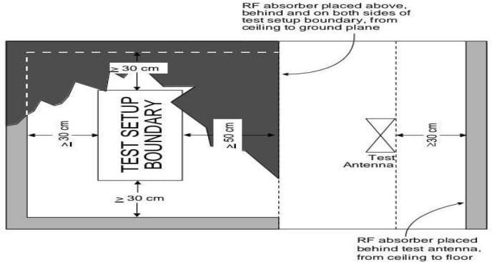**Foundation**: Similar to acoustic anechoic chambers, RF anechoic chambers have a solid, vibration-free foundation, often isolated from the rest of the building to minimize external noise and vibrations.

**Absorber Panels**: The interior surfaces (walls, floor, and ceiling) are lined with RF absorber materials, typically made from foam or rubberized materials impregnated with carbon or ferrite. These materials absorb RF energy, preventing reflections and creating a non-reflective environment.

Fig 3.2.3.1 test setup boundary

# Applications:

1. **EMI Testing**: Testing devices for electromagnetic interference to ensure they do not emit excessive RF energy that could interfere with other devices.
2. **EMC Testing**: Ensuring that devices can operate correctly in their intended electromagnetic environment without being affected by external RF interference.
3. **Antenna Testing:** Measuring the radiation patterns and performance of antennas in a controlled environment.
4. **Wireless Communication Testing:** Evaluating the performance of wireless devices such as mobile phones, Wi-Fi routers, and other RF communication equipment.
5. In summary, the construction of an RF anechoic chamber involves creating a shielded environment using a Faraday cage and lining the interior with RF absorber materials. This combination ensures that the chamber is free from external RF interference and internal reflections, providing a reliable space for EMI/EMC testing and other RF measurements.

**3.3.5 Elecromagenetic interference due to slots and apertures in chamber:**

%model shielding enclosures and analyze electromagnetic interference from slots or apertures in the enclosure excited by the interior sources. Enclosure and the interior source is modeled using custom 3-D shapes and performance is evaluated at a particular distance away from the setup.

% The integrity of shielding enclosures for high-speed digital designs is compromised by slots and apertures for heat dissipation,

% CD-ROMs, input/output (I/O) cable penetration, and plate-covered unused connector ports among other possibilities.

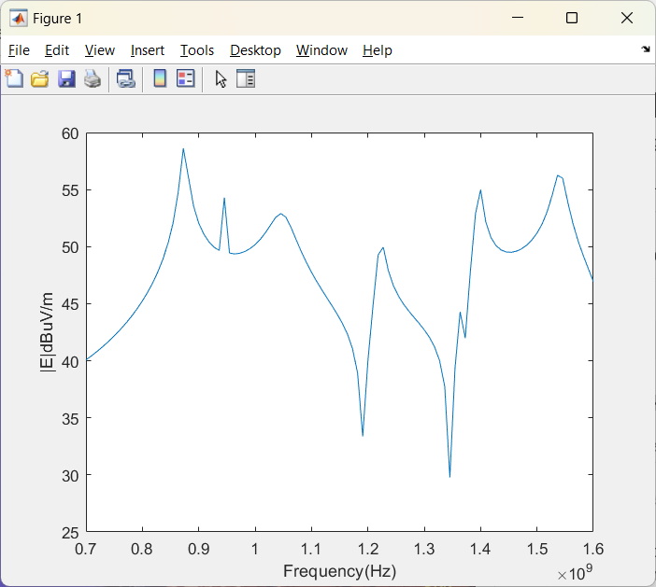

Fig 3.3.5.1 E field plot vs frequency

enclosureLength = 220e-3;

enclosureWidth = 300e-3;

enclosureHeight = 140e-3;

slotLength = 2e-3;

slotWidth = 120e-3;

box = shape.Box(Length=enclosureLength, Width=enclosureWidth, Height=enclosureHeight);

slot = shape.Box(Length=enclosureLength/2, Width=slotWidth, Height=slotLength, Color="r");

box.Transparency = 0.3;

[~] = translate(slot,[enclosureLength/2 0 -50e-3]);

boxEnclosure = box - slot;

[~] = translate(boxEnclosure,[0 0 40e-3]);

show(boxEnclosure);

feed = shape.Circle(Radius=0.8e-3, Center=[0.05 0], NumPoints=20, Color="r");

[~] = translate(feed,[0 0 -0.11]);

[~] = rotateY(boxEnclosure,180);

antShape = extrude(boxEnclosure,feed,Height=0.12);

[~] = rotateY(antShape,180);

show(antShape)

ant = customAntenna(Shape=antShape);

[~] = createFeed(ant,[-0.05 0 0.11],20);

show(ant);

[E,H] = EHfields(ant,linspace(0.7e9,1.6e9,100),[3 0 0]');

%Calculate the E-field magnitude.

Et = abs(E);

Et = sqrt(Et(1,:).^2+Et(2,:).^2+Et(3,:).^2);

plot(linspace(0.7e9,1.6e9,100),10*log10(Et./1e-6));

xlabel("Frequency(Hz)");

ylabel("|E|dBuV/m");

As seen from the E-field magnitude plot across the 700 MHz to 1.6 GHz frequency range, electromagnetic interference is significant when the larger dimension of the slot is comparable to half-wavelength at the respective frequency of operation used for plotting of the graphs.

**4. COMPONENTS USED IN EMI/ EMC TESTING:**

# Antenna

Antennas are essential components in wireless communication, including mobile phones and televisions. They convert electric power into electromagnetic waves, such as radio waves, and vice versa. Wireless devices like routers, wireless modems, game controllers, and Bluetooth devices also have antennas. Antennas are structures that help bridge the transition between guided waves and free space, converting electric power into electromagnetic waves. Infrared communication is an exception, but both devices rely on antennas. Antennas convert signals from transmission lines or guiding devices like co-axial cables into electromagnetic energy for transmission through free space. They can be used for both transmission and reception of radiation, collecting electrical signals and accepting radio waves from space.

## Antenna beam width:

Antenna beam width determines the expected signal strength given the direction and radiation distance of an antenna. The beam width will vary given several different factors such as the antenna type, design, orientation and radio frequency. Understanding beam width and how it influences a test environment is critical to accurate and repeatable tests.

4.1.1.1. How beam width is measured:

To calculate an antenna beam width, it is first important to understand directional antennas and antenna gain. Gain is more than increased signal strength. It is directly associated with antenna directionality: increased signal strength in one direction is obtained by reducing signal strength in another. Antenna gain is referenced against a theoretical, pure omnidirectional antenna that radiates power equally in all directions, in the shape of a perfect sphere. Gain is measured in decibels (dB), which is a logarithmic scale since radio frequency (RF) power drops logarithmically with distance. All of these components of gain are important to consider during product testing to ensure that tests are correct, accurate and repeatable. The half-power value, also called the -3 dB point, which is represented by the red lines in below figure determines and defines the main RF lobe and its width, or beam width.

4.1.1.2 **Accounting for different antennae and frequencies:**

Antennas have a specific beam width pattern, but this pattern is not consistent across all frequencies. When testing, consider the frequency of operation to account for beam width differences. Higher frequencies have a narrower beam width and are more directional. The divergence of the beam is related to frequency by a formula, making it easy to account for these effects. A typical test setup in an anechoic chamber with a log periodic antenna, where its beamwidth at 1 m covers 0.536 m2 of testing area.

This demonstrates the necessity of calculating the required testing distance relative to beamwidth and antenna. Antenna design plays a crucial role in selecting the best antenna for each test, considering factors like resonant frequency, bandwidth, polarization, and gain. Log periodic antennas have wide-frequency bandwidth and directionality, and their beamwidth is used for half-power testing. The half-power beamwidth and distance to the device under test provide the necessary information for setting up a test environment.

## 4.1.2 Gain:

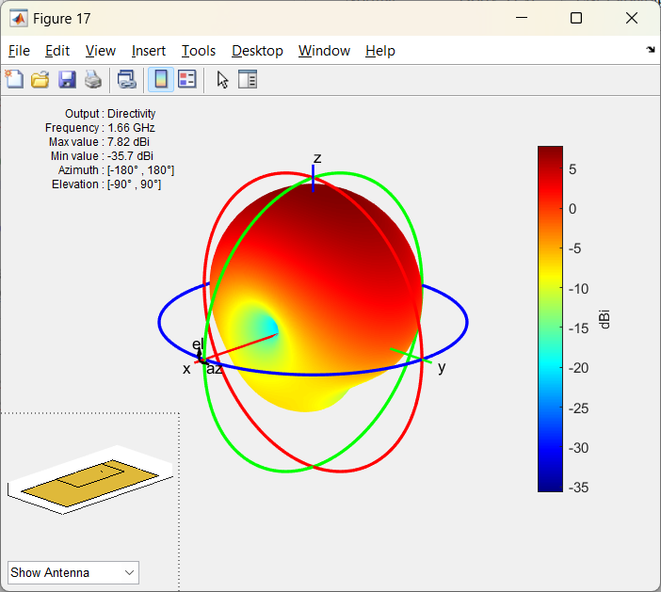Gain : The extent to which an antenna focuses energy. In general, gain is measured and directivity is calculated Efficiency (dB) = Directivity (dB) – Gain (dB).

In a transmitting antenna, the gain describes how well the antenna converts input power into [radio waves](https://en.wikipedia.org/wiki/Radio_wave) headed in a specified direction. In a receiving antenna, the gain describes how well the antenna converts radio waves arriving from a specified direction into electrical power. When no direction is specified, gain is understood to refer to the peak value of the gain, the gain in the direction of the antenna's [main lobe](https://en.wikipedia.org/wiki/Main_lobe). A plot of the gain as a function of direction is called the antenna pattern or [radiation pattern](https://en.wikipedia.org/wiki/Radiation_pattern)

* + 1. **Antenna measurements:**

Fig 4.1.3.1 Gain plot of antenna with matlab 5-A

An isotropic radiator is a theoretical point source of electromagnetic energy that radiates uniformly in all directions. The absolute power used is an isotropic radiator, and the measured gain relative to it is expressed in dB. Directivity, calculated using antenna pattern or design parameters, should always be greater than the actual measured gain.

## Antenna impedance:

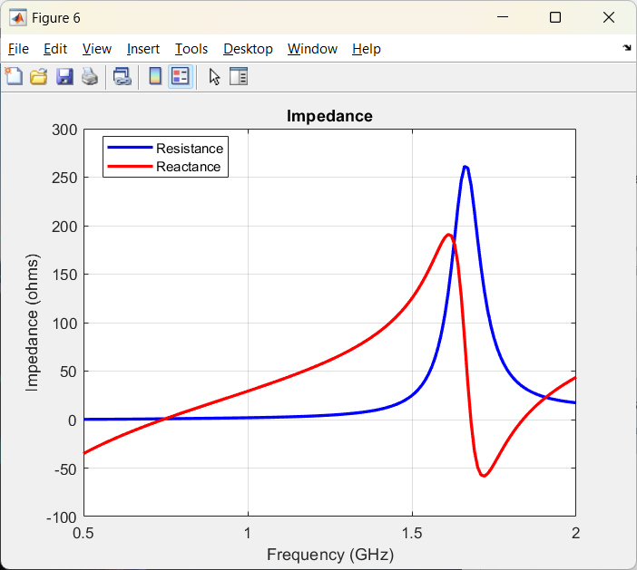The antenna impedance (in ohms) is the impedance value seen at the antenna terminals. This does not mean the DC resistance, but the radiation resistance (whose job is to convert the incoming signal to radiation) which varies with the frequency. As a result, using the antenna outside of its designed frequency will change its feed point impedance to an incorrect value.

Fig 4.1.4 Impedance curve using matlab

The antenna impedance (resistive and reactance components vary with the occurring frequency range)

## 4.1.5 Universal spectral dipole source:

Applied Electromagnetic Technology, LLC (AET) offers the Universal Spherical Dipole

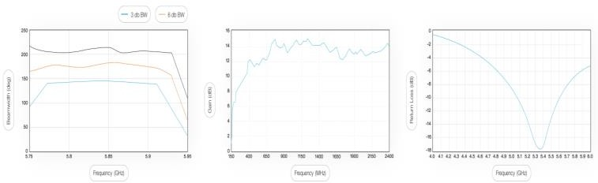

Fig 4.1.5.2 Bandwidth,gain,pattern loss

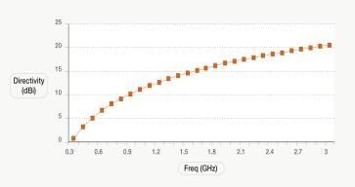

Fig 4.1.5.1 directivity vs frequency

Source (USDS), a broadband electric field comb generator RF source with Quasi-Peak detector test functionality.

The USDS is traceable to the Precision Spherical Dipole Source (PSDS) design, developed by NIST. It is ideal for RF emission site comparisons, shielding measurements, quasi-peak detector verification, and verification of RF laboratory equipment. The USDS's spherical dipole antenna offers a highly uniform radiation pattern, easy use, and a small, 10 cm size for shielding effectiveness tests

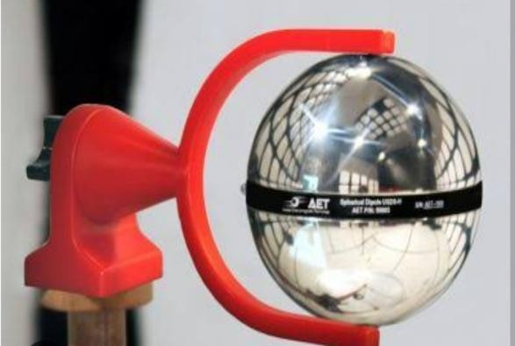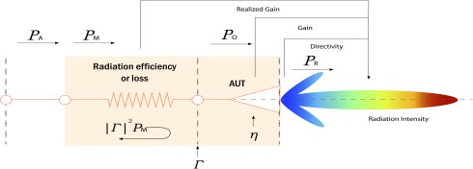

Fig4.1.5.4 Radiation efficiency plot

Fig4.1.5.3 USDS

* + 1. 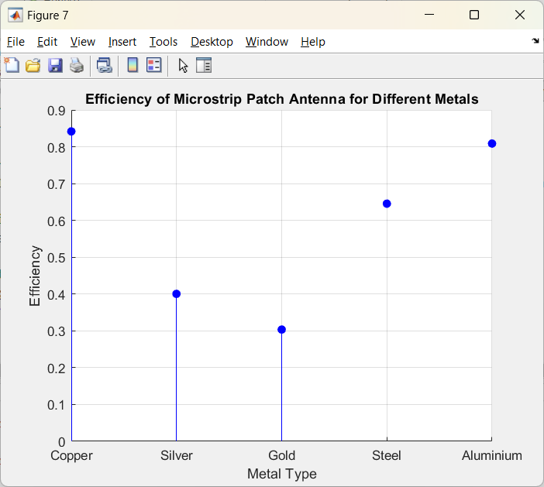**Effect of meatal used for antenna design:**

**4.1.6.1. Conductivity**

* **Higher Conductivity:** Metals with higher electrical conductivity, such as copper, silver, and aluminum, are more efficient in transmitting electromagnetic signals. High conductivity reduces resistive losses, allowing more of the input power to be radiated as electromagnetic waves.
* **Lower Conductivity:** Metals with lower conductivity, like stainless steel or brass, result in higher resistive losses, leading to reduced antenna efficiency. The energy lost as heat due to resistance reduces the power available for radiation.

Fig 4.1.6.1 Efficiency plot for metals

**4.1.6.2. Surface Roughness**

* **Smooth Surfaces:** A smoother metal surface reduces the skin effect, where high-frequency currents flow primarily on the surface of the conductor. Smoother surfaces have lower resistance, which leads to lower energy loss and higher efficiency.
* **Rough Surfaces:** Metals with rougher surfaces increase resistance due to the skin effect, which in turn decreases the antenna's efficiency by causing greater power losses.

**4.1.6.3. Thermal Conductivity**

* **High Thermal Conductivity:** Metals with high thermal conductivity, like copper, can dissipate heat more effectively. This property is essential in high-power antennas, where excessive heat can cause inefficiency or damage.
* **Low Thermal Conductivity:** Metals with poor thermal conductivity may overheat during operation, leading to increased resistance and reduced efficiency.

**4.1.6.4. Magnetic Properties**

1. **Non-Magnetic Metals:** Most efficient antennas are made from non-magnetic metals like copper and aluminum. These metals do not interact with magnetic fields, ensuring stable performance across different frequencies.
2. **Magnetic Metals:** Ferromagnetic metals like iron can introduce unwanted inductance and affect the magnetic field distribution, which can degrade antenna efficiency.

**4.1.7 Efficiency of antennas:**

The efficiency of antennas is influenced by their shape, which determines factors such as radiation pattern, bandwidth, and impedance matching. Here are some common antenna shapes along with relevant formulas to evaluate their efficiency:

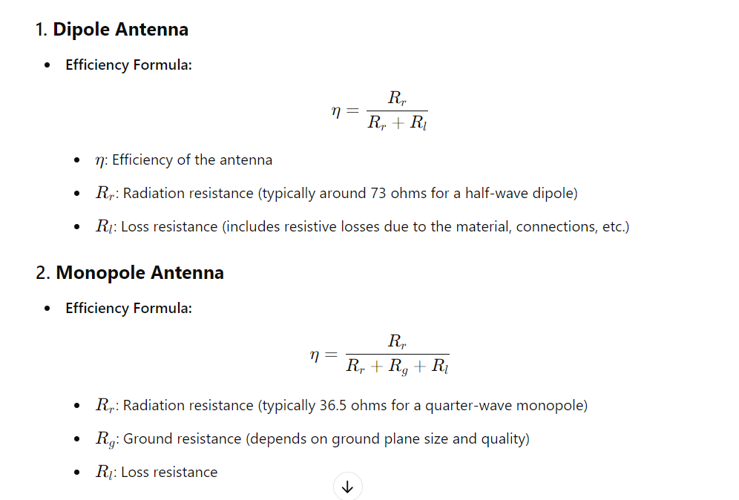

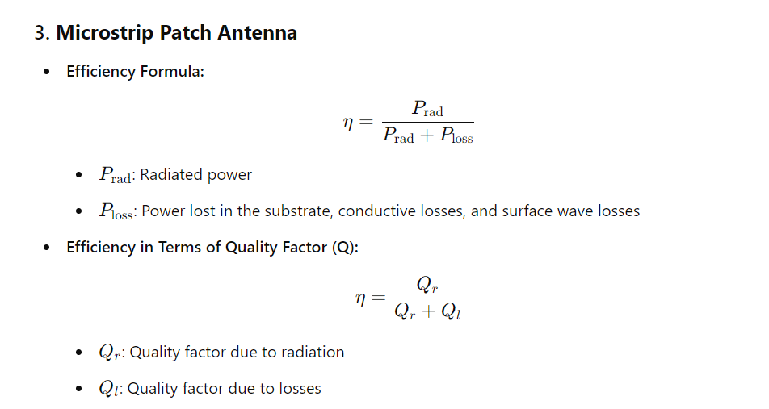

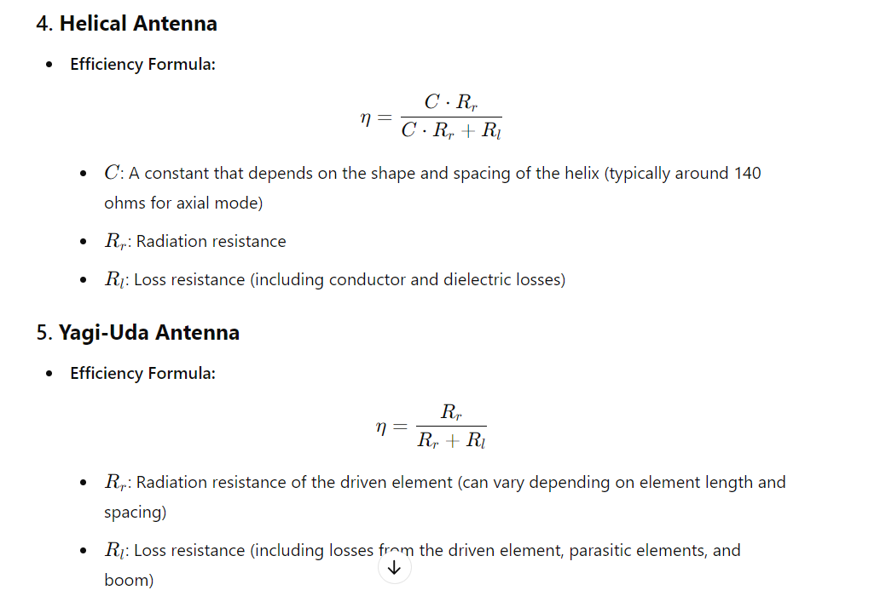

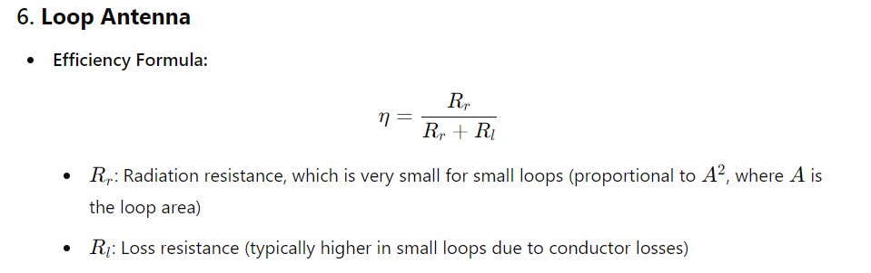

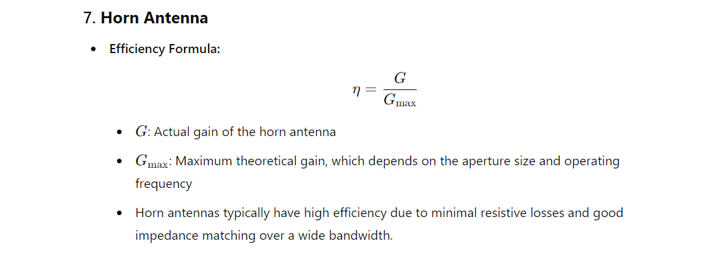

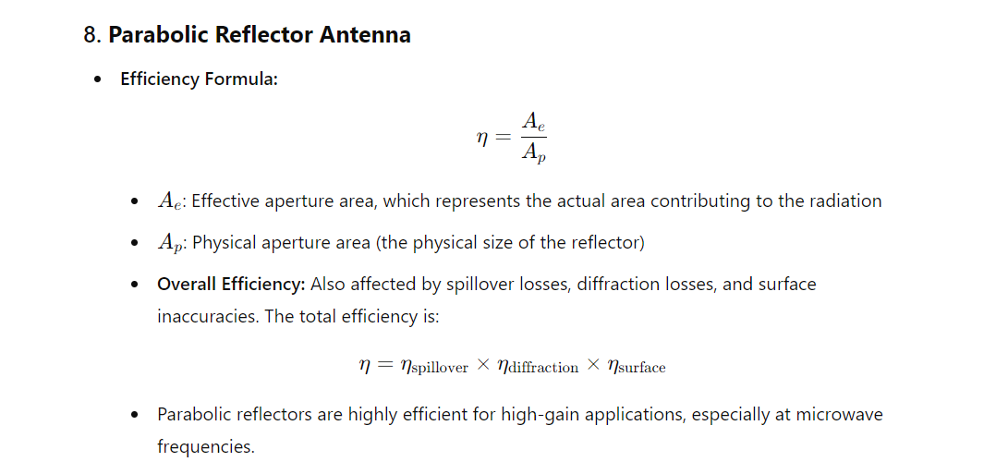

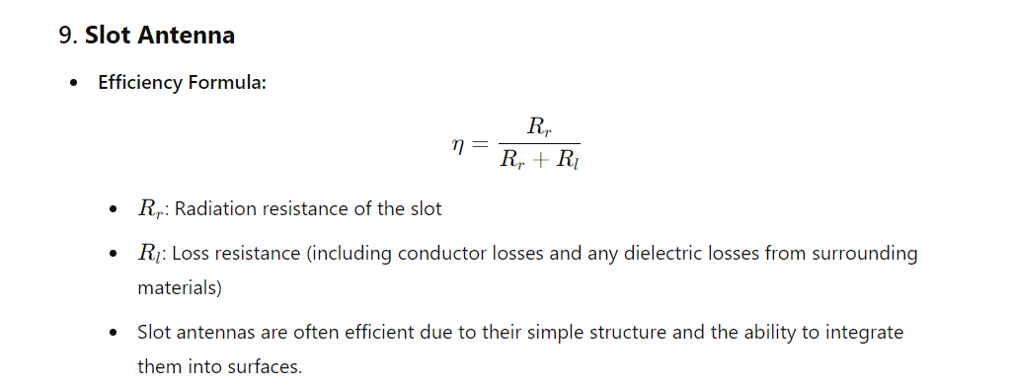

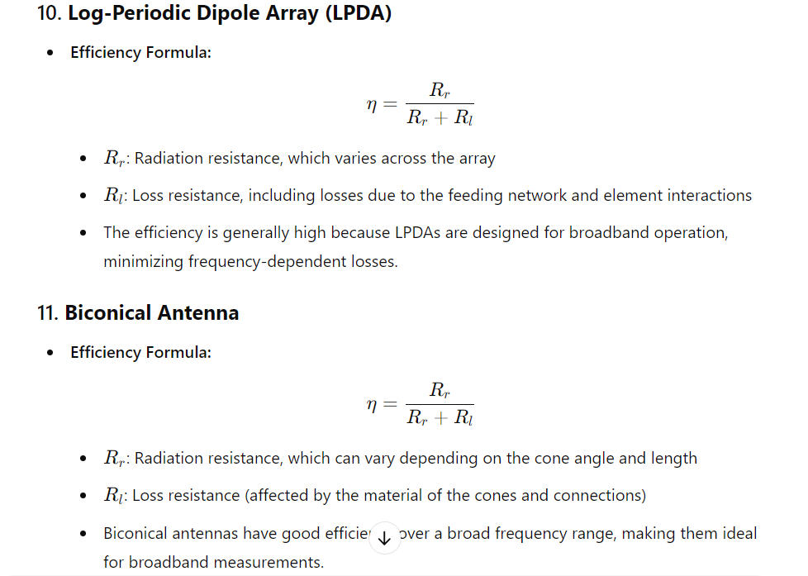

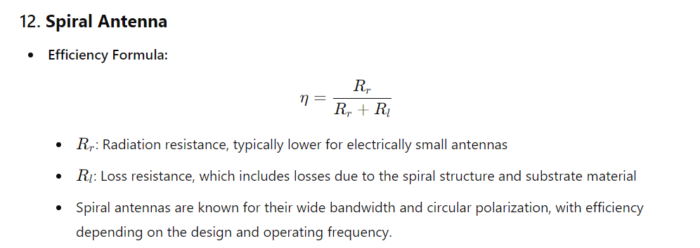

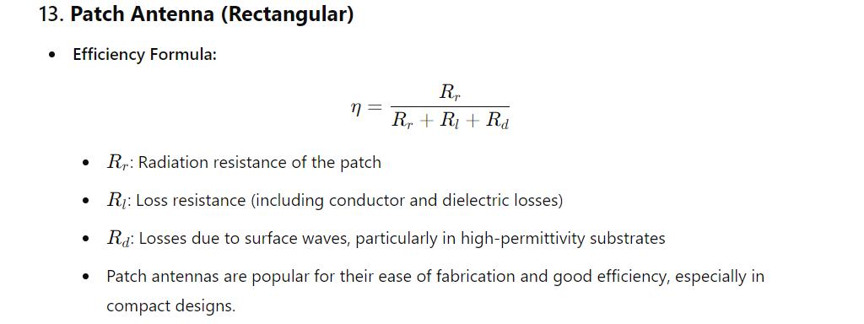

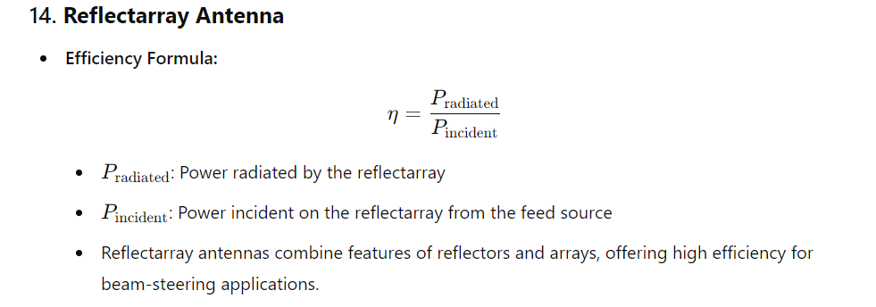

**4.1.7.1 General Factors Affecting Efficiency Across Different Shapes:**

1. **Radiation Resistance (RrR_rRr​)**: Represents the power radiated by the antenna. Higher radiation resistance generally leads to higher efficiency.
2. **Loss Resistance (RlR_lRl​)**: Represents the power lost due to resistive heating, dielectric losses, and other non-radiative losses. Lower loss resistance improves efficiency.
3. **Antenna Quality Factor (Q):** Indicates the bandwidth over which the antenna operates efficiently. Lower QlQ_lQl​ (loss quality factor) improves efficiency.

**4.1.8 Directivity:**

**Directivity** is a measure of how concentrated the radiation pattern of an antenna is in a particular direction compared to an isotropic antenna, which radiates equally in all directions. It is a key parameter in antenna theory and design, as it indicates the ability of an antenna to focus energy in a specific direction.

**4.1.8.1. Definition of Directivity**

**Directivity (D)** is defined as the ratio of the maximum power density (in the most focused direction) to the average power density radiated in all directions.

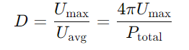

**U max** Maximum radiation intensity (power per unit solid angle) in the direction of the strongest radiation.

**Uavg​**: Average radiation intensity over all directions.

**Ptotal​**: Total radiated power by the antenna.

**4.1.8.2. Expressing Directivity in Decibels**

Directivity is often expressed in decibels (dB) for convenience:

DDdB​=10log10​D

**4.1.8.3. Isotropic Antenna**

An isotropic antenna, which radiates equally in all directions, has a directivity of 1 (or 0 dB).

**4.1.8.4. Typical Directivity Values for Different Antennas:**

1. **Dipole Antenna:** The directivity of a half-wave dipole is approximately 2.15 dB.
2. **Monopole Antenna:** For a quarter-wave monopole, the directivity is approximately 5.15 dB.
3. **Patch Antenna:** A typical rectangular microstrip patch antenna has a directivity in the range of 6-9 dB.
4. **Yagi-Uda Antenna:** The directivity varies but can range from 7 dB to over 20 dB depending on the number of elements.
5. **Parabolic Reflector Antenna:** The directivity can be very high, often exceeding 30 dB, depending on the size of the reflector.
6. **Horn Antenna:** Typically has a directivity ranging from 10 dB to over 20 dB.

**4.1.8.5. Relation Between Directivity and Beamwidth:**

1. There is an inverse relationship between directivity and beamwidth (the angular width of the main lobe of the radiation pattern

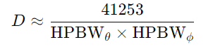

**HPBWθ** Half-power beamwidth in the horizontal plane.

**HPBWϕ** Half-power beamwidth in the vertical plane.

The narrower the beamwidth, the higher the directivity.

**4.1.8.6. Directivity and Gain:**

**Gain** (G) is related to directivity but also takes into account the efficiency (η\etaη) of the antenna: G=η×D

**η\eta** Efficiency of the antenna, accounting for losses due to resistance, material imperfections, etc.

If an antenna is 100% efficient, its gain equals its directivity.

* + 1. **Types Of Antennas**

## 4.1.9.1Active Monopole Antenna SAS-550-1B:

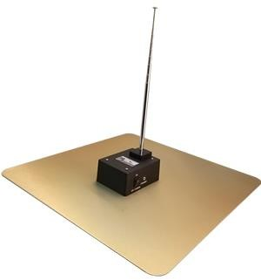**Characteristics**:

4.1.9.1.1 Active monopole antenna

|  |  |
| --- | --- |
| Frequency Range: | 9 KHz - 60 MHz |
| Antenna Factor: | 0 dB/m |
| Impedance: | 50 ohm |
| Pattern Type: | omnidirectional |
| Output Connector: | BNC-Type, female |
| Mounting Base: | 1/4 - 20 Thread, female |

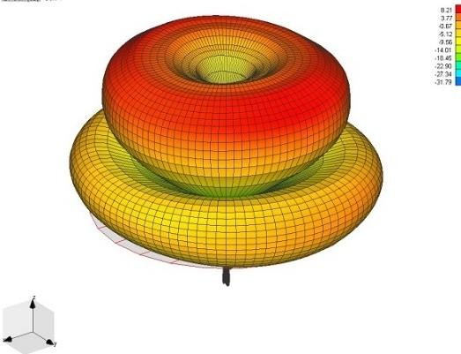SAS-550-1B active monopole antenna is ideal for instantaneous bandwidth scanning (without tuning) of electric fields from 9 KHz - 60 MHz. It's well

suited for test technicians performing FCC, MIL-STD and CISPR low-frequency tests. The active monpole antenna was recently redesigned to accept a telescoping rod with a 1/4-20 thread, instead of a BNC connector, which makes for a better electrical performance as well as an improved rugged design.

## TDK PBA – 2030 Biconical Antenna:

4.1.9.1.2 Gain plot of monopole antenna

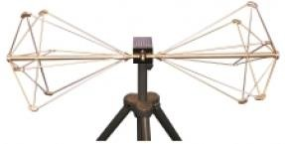**Characteristics :**

Frequency Range: 20 MHz to 300 MHz VSWR: 2.5:1 average

Polarization: Linear

Power Handling: 100 W maximum

Fig 4.1.9.2.1 TDK PBA biconical

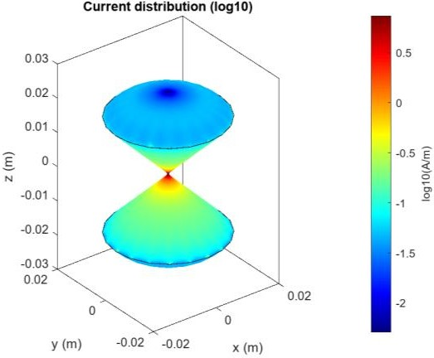

The TDK PBA-2030 Precision Biconical Antenna is a new generation biconical dipole with linear polarizations that covers the operating frequency range of 20 MHz to

300 MHz. It’s moderate power handling capability accommodates the majority of immunity testing applications. The PBA-2030 features an improved biconical element (patent pending) and improved balun design, which provides superior patterns and balance. An additional feature of the PBA-2030 is its highly effective internal choke, which provides immunity to externally induced imbalance.

Fig 4.1.9.2.2 Current distribution

**4.1.9.3 EFG03 E-Field Generator Characteristics:**

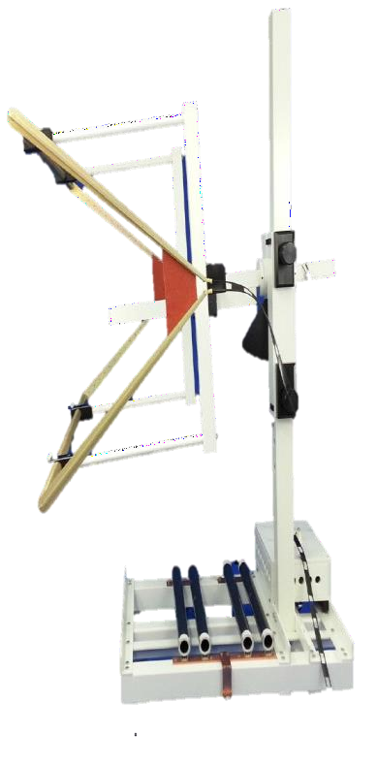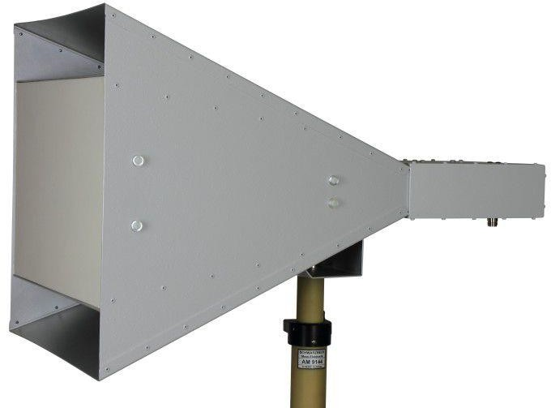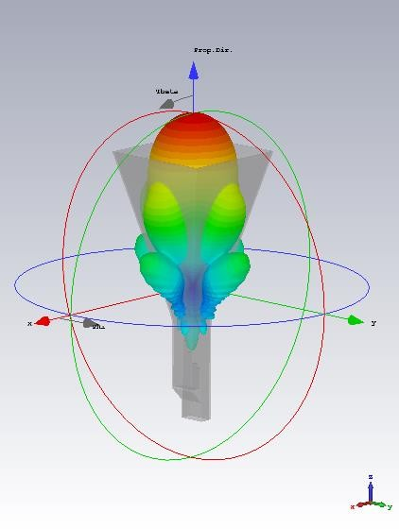

Input Power: 3.5 kW Operation Frequency Range: 10 kHz – 100 MHz Input Impedance: 50 ohms

The TDK EFG-03 is an E-field generator designed to produce controlled, high-intensity electric fields over the frequency range of 10 kHz to 100 MHz. The EFG-03 generates a minimum of 500 V/m between the elements. Its capability to handle high input power and its low VSWR make the EFG-

03 a powerful and effective E-field generator. It utilizes an external load that permits the field generator to handle input power up to 3500 Watts (continuous) without the use of forced air or water cooling. This makes the EFG-03 ideal for immunity test applications which require high input power, high intensity fields in a compact design.

Fig 4.1.9.3.1 Efield generator

## Schwarzbeck Horn Antenna BBHA9120J

**Characteristics:**

|  |  |
| --- | --- |
| Frequency Range: | 800 MHz –  6.2 GHz |
| Impedance: | 50 ohm Nominal |
| Pattern Type: | directional |
| Polarization: | Linear |
| Connector: | N (optional 7/16) |

Fig 4.1.9.4.1. Horn antenna gain plot

The broadband horn antenna BBHA 9120 J is a linear polarized high gain antenna for the frequency range 800 MHz to 6.2 GHz. The gain increases from 11 dB at 1GHz up to more than 20 dB at higher frequencies.

Fig 4.1.9.4.2 Horn antenna side view

# VECTOR NETWORK ANALYSER

Vector Network Analysers (VNA) are versatile instruments for RF test and measurement applications, combining generators and receivers in a single box. They work in a wide frequency range and have powerful computers for fast data processing and controlling external equipment. The combination of VNAs and external switch matrices increases flexibility in RF test applications, allowing simultaneous testing of multiple test objects, complex digitally controlled RF modules, and simultaneous connection of prototypes as indicated in Fig1.

# Vector Network Analyzer | Siglent Network Analyzer | VNAVNA vs Spectrum Analyzer

The OSP switch matrix can be set and its effects observed simultaneously at the VNA. The entire configuration can be stored permanently using "paths" with appropriate pathnames.

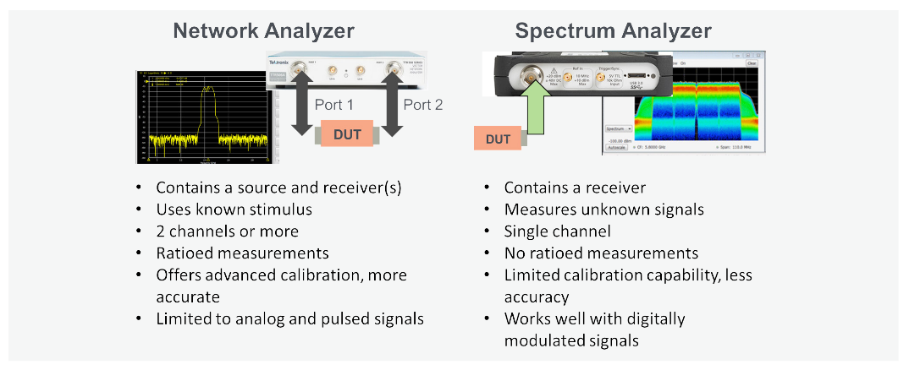The OSP panel software can be closed once all paths are defined and stored. This solution is useful for a Spectrum Analyzer (SA) in 2-port analysis, especially when switching RF paths or modifying DC bias values using digital outputs.

Figure 4.2.1.2 difference VNA and SA

Fig 4.2.1.1 VNA rohde & Schwarz

**4.2.2 Typical VNA Measurements:**

VNA’s perform two types of measurements – transmission and reflection .Transmission measurements pass the VNA’s stimulus signal through the DUT, which is then measured by the VNA receivers on the other side. The most common transmission S-parameter measurements are S21 and S12 (Sxy for greater than 2-ports). Swept power measurements are a form of transmission measurement. Some other examples of transmission measurements include gain, insertion loss/ phase, electrical length/delay and group delay. Comparatively, reflection measurements measure the part of the VNA stimulus signal that is incident upon the DUT, but does not pass through it. Instead, the reflection measurement measures the signal that travels back towards the source due to reflections. The most common reflection S-parameter measurements are S11 and S22 (Sxx for greater than 2-ports).

**4.2.3 SWEPT FREQUENCY MEASUREMENTS**

Swept frequency measurements are particularly useful because they sweep the internal source across a user defined set of frequencies and step points. A wide variety of measurements can be made from this including S-parameters, individual incident and reflected waves (e.g. a1 , b2 ), magnitude, phase, etc. fig 4.2.3.1 shows an example of a swept frequency transmission measurement of a passive filter. This type of filter measurement shows what happens to the signal as it passes through the component. The S21 measurement indicates the passband bandwidth performance as defined by its 6 dB response. The stopband performance is displayed as compared to a 60 dB reduction specification. The measured result can then be compared with the *filter design goals or, from the system designer's perspective, the filter manufacturer’s specification.*

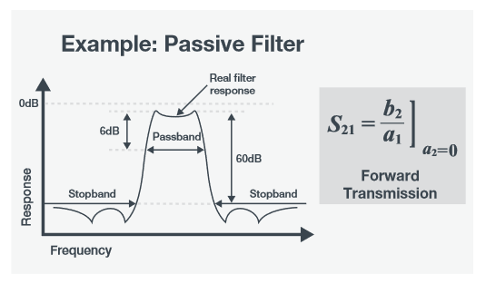

Fig 4.2.3.1 s21 for passive filter characteristics

Swept frequency transmission measurement example of a passive filter.

Swept frequency measurements may also measure reflections of the stimulus signal that are incident on the DUT, but are reflected as opposed to being transmitted through the DUT. These S11 (or Sxx) measurements allow the user to check and compare the performance of the DUT to its specification. Example DUTs include antennas, filters, and duplexers.

# Need of VNA

Wireless solutions, including smartphones, WiFi networks, connected cars, and IoT devices, use transmitters and receivers with RF and microwave components. VNAs are used to test component specifications and verify design simulations, ensuring system functionality. They are commonly used by R&D engineers and manufacturing test engineers at various stages of product

development, component designers, system designers, manufacturing lines, and even in field operations to verify and troubleshoot deployed RF and microwave systems.

Fig . 4.2.2.1 menus in VNA

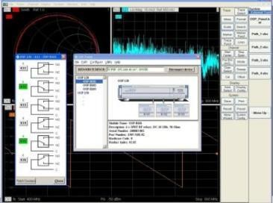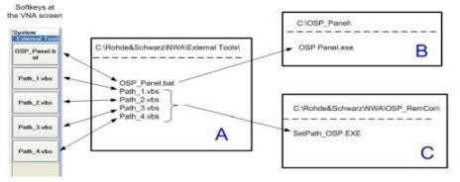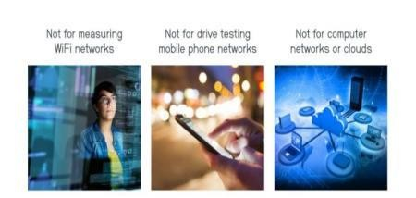

**4.2.5 BASIC VNA OPERATION**

One unique feature of a VNA is that it contains both a source, used to generate a known stimulus signal, and a set of receivers, used to determine changes to this stimulus caused by the device-under-test or DUT. The source can be taken coming from Port 1, but most VNAs today are multipath instruments and can provide the stimulus signal to either port.

The stimulus signal is injected into the DUT and the VNA measures both the signal that's reflected from the input side, as well as the signal that passes through to the output side of the DUT. The VNA receivers measure the resulting signals and compare them to the known stimulus signal. The measured results are then processed by either an internal or external PC and sent to a display.

There are a variety of different VNAs available on the market, each with a different number of ports and paths for which the stimulus signal flows. In the case of a 1-port VNA, the DUT is connected to the input side of Figure 5 and only the reflected signals can be measured. For a 2-port 1-path VNA, both the reflected and transmitted signal (S11 and S21) can be measured, however, the DUT must be physically reversed to measure the reverse parameters (S22 and S12). As regards

to a 2-port 2-path VNA, the DUT can be connected to either port in either direction because the instrument has the capability of reversing the signal flow so that the reflections at both ports (S11 and S22), as well as the forward and reverse transmissions (S21 and S12), can be measured.

# Key specifications :

To select a VNA, consider four top-level specifications: frequency range, dynamic range, trace noise, and measurement speed. Frequency range is crucial, considering both immediate and future needs. Active components may need to be tested at their harmonic frequencies, which can be a cost driver. Dynamic range is the measurable attenuation range from max to min for a specified frequency range. Most VNAs offer good dynamic range (~120 dB), but high- performance components may require more expensive solutions.

# Understanding S-Parameters:

Scattering parameters or S-parameters are used to characterize the electrical properties or performance of an RF component or network of components. They are related to familiar measurements such as gain, loss, and reflection coefficient. A VNA (Visual Network Analyzer) is used to characterize a DUT by using incident and reflected waves as excitations at each port. The S-parameters are constants that characterize the network under these conditions.

In the Forward case, the S-parameters correspond to the reflection coefficient at Port 1 and the forward transmission coefficient through the DUT. In the Reverse case, the S-parameters

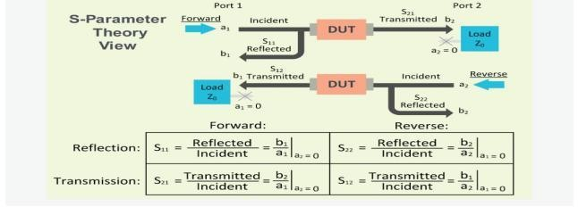

Fig 4.2.4.1 S parameter calculation

correspond to the reflection coefficient at Port 2 and the reverse transmission coefficient through the DUT.

**4.2.8 SCPI COMMANDS IN VNA:**

SCPI is a Python-based collection of mathematical algorithms and convenience functions, offering high-level commands and classes for data manipulation and visualization. It rivals systems like MATLAB, IDL, Octave, R-Lab, and SciLab.

Basing SCPI on Python allows for sophisticated programming and specialized applications, including parallel programming, web and database subroutines, and classes, making it a powerful tool for Python developers.

**4.2.9 EXAMPLES DEVELOPED:**

#The diagram area in a VNA typically refers to the graphical display where measurement results such as S-parameters (scattering parameters) are plotted.

* 1. Display screen

from rohdeschwarz.instruments.vna import Vna

# Connect

vna = Vna()

vna.open_tcp()

vna.write('DISP:RFS 80')

vna.write(':DISP:WIND:TRAC:X:OFFS 1MHZ; ')

#display window trace offset x axis

vna.query('DISP:WIND:TRAC:Y:OFFS? ')

#Querying all the traces

vna.write("CALC4:PAR:SDEF 'Ch4Tr1', 'S11' ")

# Create channel 4 and a trace named Ch4Tr1 to measure the input reflection

# coefficient S11.

vna.write('DISP:WIND2:STAT ON ')

#Create diagram area no. 2.

vna.write("DISP:WIND2:TRAC9:FEED 'CH4TR1' ")

# Display the generated trace in diagram area no. 2, assigning the trace number

# 9 to it.

vna.write('DISP:WIND2:TRAC9:Y:RLEV -10 ')

# # DISP:WIND2:TRAC9:Y:RLEV -10

# # or: DISP:WIND2:TRAC:Y:RLEV -10, 'CH4TR1'

# Change the reference level to –10 dB.

2.Pulse generation:

from rohdeschwarz.instruments.vna import Vna

# Connect

vna = Vna()

vna.open_tcp()

vna.write('SENS1:PUL:GEN1:TR:DA')

#gen number

# 1 for pulse generator, 2 for sync

vna.write('SENS1:PUL:GEN1:PER125NS')

vna.query('SENS1:PUL:GEN1:TR:SEGM:CO?')

#Pulse train segment number. This suffix is ignored; the command counts all segments.

seg=1

scpi='SENS1:PUL:GEN1:TR:SEGM{}:ST5'

vna.write(scpi.format(seg))

'''Parameters SINGle – Single pulse

CHIGh – Constant high

CLOW – Constant low

TRAin – Pulse train (available for pulse generator signal only, <gen_no> = 1)'''

vna.write('SEN1:PUL:GEN1:TYTR')

vna.write('SENS1:PUL:GEN1:TR:SEGM[:STE]OFF')

vna.write('SENS1:PUL:GEN1:TR:DELE:ALL')

'''Range [def.

unit]

12.5 ns to 54975.5813632 s [s]. The minimum width of a pulse is 12.5 ns, its

maximum width is given by the pulse train period

([SEN<CH>:]PUL:GEN<GEN_NO>:TR:PER).'''

3)REFLECTION COEFFICIENT:

from rohdeschwarz.instruments.vna import Vna

import time

# Connect

vna = Vna()

vna.open_tcp()

vna.write(':SYST:DISP:UPD ON')

vna.write("CORR:COLL:METH:DEF 'Test1',RSHort,1 ")

vna.write('CORR:COLL:SEL SHOR,1 ') #calibration sweep

vna.write('CORR:COLL:SAVE:SEL ')

time.sleep(300)

#Define a reflection normalization with a Short standard at port 1, perform the

#calibration sweep, and apply the calibration to the active channel.

vna.write("CORR:COLL:METH:DEF 'Test2',REFL,1 ")

vna.write("CORR:COLL:SEL OPEN,1")

vna.write('CORR:COLL:SAVE:SEL')

#Define a reflection normalization with an Open standard at port 2, perform the

#calibration sweep, and apply the calibration to the active channel.

vna.query('CORRection:DATA:PARameter1? TYPE ')

#Query the calibration type of the first calibration. The response is RSH.

vna.query('CORRection:DATA:PARameter2? TYPE')

#Query the calibration type of the second calibration. The response is REFL.

vna.query('CORRection:DATA:PARameter:COUNt? ')

#Query the number of active calibrations. The response is 2.

# REFL

# RSH

# Refl Norm Open

# Refl Norm Short

4) SCREENSHOT CAPTURE:

from rohdeschwarz.instruments.vna import Vna

# Connect

vna = Vna()

vna.open_tcp()

temp_filename = 'temp.png'

local_filename = 'screenshot.png'

scpi = ":MMEM:NAME '{0}'"

scpi = scpi.format(temp_filename)

vna.write(scpi)

# Set format

# Options include:

# - BMP

# - PNG

# - JPG

# - PDF

# - SVG

vna.write(":HCOP:DEV:LANG PNG")

# Set contents of screenshot

# to entire screen

vna.write(":HCOP:PAGE:WIND HARD")

# - OR -------------------------

# Set active diagram

diagram = 1

scpi = "DISP:WIND{0}:MAX 0"

scpi = scpi.format(diagram)

vna.write(scpi)

# Set contents of screenshot

# to active diagram

scpi = ":HCOP:PAGE:WIND ACT"

#hard copy of the page in active diagram region

vna.write(scpi)

# ------------------------------

# Set destination to file

vna.write("HCOP:DEST 'MMEM'")

# Save file

# Wait for save to complete

vna.write(":HCOP")

vna.query("*OPC?")

# Copy screenshot off vna

# (See file_transfer.py for details)

vna.file.download_file(temp_filename, local_filename)

# Delete temp file off vna

# Wait for delete to complete

scpi = "MMEM:DEL '{0}'"

scpi = scpi.format(temp_filename)

vna.write(scpi)

vna.query("*OPC?")

vna.close()

5) S PARAMETER CALCULATION:

#calculation of all the s parameters

import time

import pyvisa

timeout=30000

address='GPIB0::6::INSTR'

with pyvisa.ResourceManager('@py').open_resource(address) as vna:

vna.timeout = timeout # Set time out duration in ms

vna.clear()

vna.write(':SYSTem:DISPlay:UPDate ON') # display in the screen updates while in remote control

# Reset the instrument, add diagram areas no. 2, 3, 4.

vna.write('*RST; :DISPlay:WINDow2:STATe ON')

vna.write('DISPlay:WINDow3:STATe ON')

vna.write('DISPlay:WINDow4:STATe ON')

time.sleep(100)

# Assign the reflection parameter S11 to the default trace.

vna.write_str_with_opc(":CALCulate1:PARameter:MEASure 'Trc1', 'S11' ")

#Assign the remaining S-parameters to new traces Trc2, Trc3, Tr4;

vna.write('CALCulate1:FORMat SMITh')

time.sleep(10)

vna.write_str_with_opc("CALCulate1:PARameter:SDEFine 'Trc2', 'S21'")

vna.write_str_with_opc("CALCulate1:PARameter:SDEFine 'Trc3', 'S12' ")

vna.write_str_with_opc("CALCulate1:PARameter:SDEFine 'Trc4', 'S22'")

vna.write('CALCulate1:FORMat SMITh')

time.sleep(10)

vna.write("DISPlay:WINDow2:TRACe2:FEED 'Trc2'")

vna.write("DISPlay:WINDow3:TRACe3:FEED 'Trc3' ")

vna.write("DISPlay:WINDow4:TRACe4:FEED 'Trc4' ")

vna.write('SYSTem:DISPlay:UPDate ONCE')

#shouldnt be necessary

# EMI Receiver

* + 1. **Resolution bandwidth (RBW):**

Spectrum analyzers are useful tools for broadcast monitoring, RF component testing, and EMI troubleshooting. There are a number of common adjustments available with many modern analyzers that can optimize performance for a particular application. In this application note, we will introduce resolution bandwidth (RBW) and video bandwidth (VBW) and how they affect measurements.Bandwidth is defined as the span of frequencies that are the focus of a particular event. For example, the bandwidth of the transmission signal is the span of frequencies that the transmission occupies. The bandwidth of a measurement defines the range of frequencies that were used for the measurement.Ideally, you would like to set this bandwidth as narrow as possible, as that would give you the finest frequency resolution. The tradeoff is sweep time. The narrower the resolution bandwidth, the longer the sweep time, but if you sent the RBW too wide, you won’t see signals that are close to one another.In spectrum analysis, the resolution bandwidth (RBW) is defined as the frequency span of the final filter that is applied to the input signal. Smaller RBWs provide finer frequency resolution and the ability to differentiate signals that have frequencies that are closer together.

* + 1. **Phase Noise:**

Another factor that affects the frequency resolution of an analyzer is the phase noise. This is observed as a widening and increase in the noise amplitude near the center frequency of the signal. It is caused by the random thermal fluctuations of the oscillator used as a timing reference in the spectrum analyzer circuitry. These fluctuations cause the phase of the output clock signal to vary with time, very similar to jitter in a time-based system. This widening can cover up any small signals that may be near the frequency of interest. For meaningful measurements, select an instrument with lower phase noise than the signal source you are measuring.

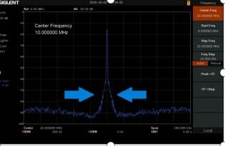

Fig 4.3.2.1 Phase noise

**4.3.3 Conversions related to Power and dB**

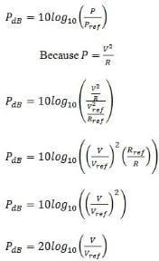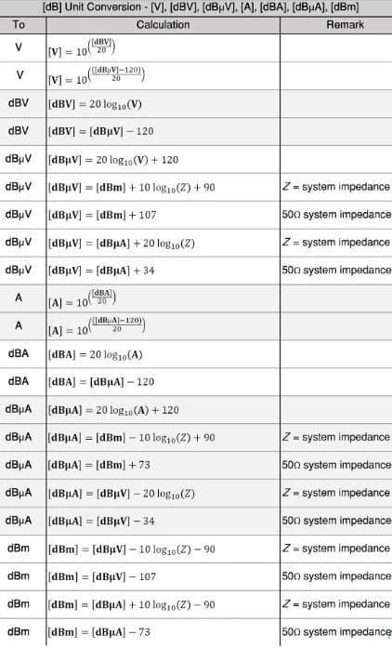

Fig 4.3.3.1 power in dB conversion

Fig 4.3.3.2 power in dB conversion

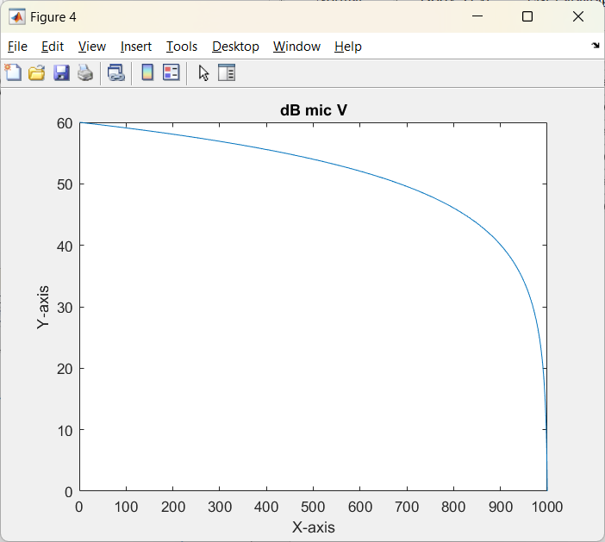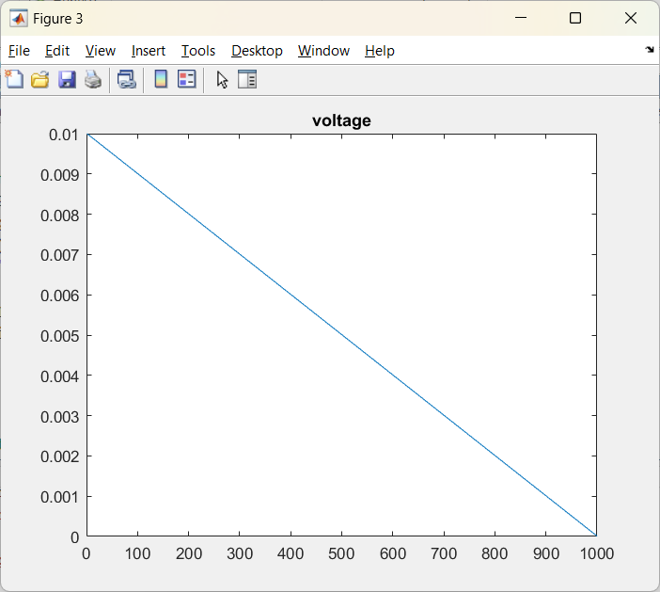

Fig 4.3.3.4 voltage plot in dB micro V

Fig 4.3.3.3 Voltage plot linear

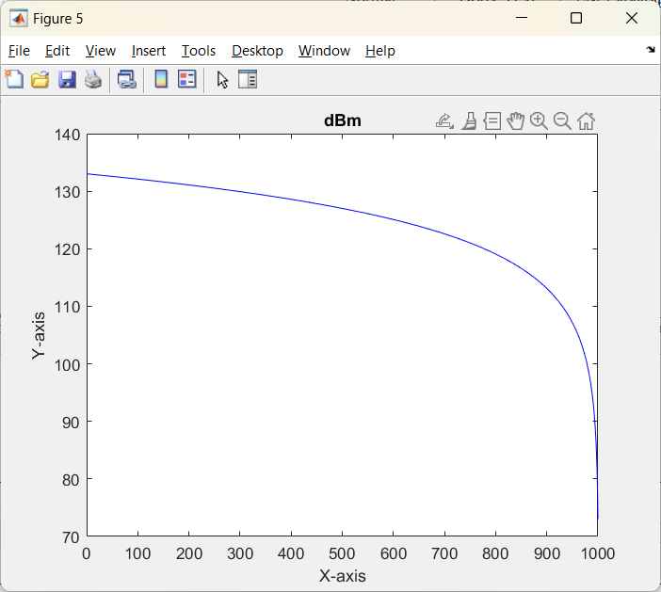**Conversions used:**

**For conversion to db micro v:**

for i=1:length(x)

x(i)=20*log10(x(i)/10e-6);

end

**for conversion to dbm from db micro v:**

% Convert to dBm

for i = 1:length(x)

x1(i) = x(i) - 10*log10(50) + 90;

end

Fig 4.3.3.5 Conversion to dBm

**5. Insertion Loss Measurement of Direction Coupler using VNA**

Insertion loss, also known as attenuation, is a measure of how much signal power is lost as it passes through an EMI/EMC filter. It is expressed in decibels (dB) and is typically a negative value because the filter’s primary function is to reduce or attenuate unwanted signals.The relationship between insertion loss and frequency for several different filter circuit configurations with a full load in a balanced 50 Ω system.Insertion loss is a critical performance metric that determines how effectively the filter attenuates unwanted EMI signals and reduces their impact on sensitive electronic components.

* 1. **Directional Coupler:**

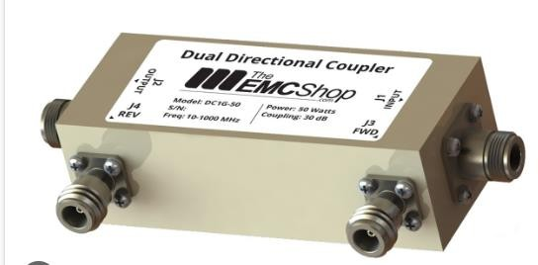

Fig 5.1.1 Direction coupler

[Directional couplers](https://www.werlatone.com/resources-directional-couplers/) are versatile aids when measuring RF/microwave power levels. Directional and bi-directional couplers provide the means to sample a small portion of the RF

/ microwave signal power through a transmission line with minimal disruption to the main line. Teamed with RF / microwave test instruments such as spectrum analyzers or electromagnetic- interference (EMI) receivers, couplers can provide sampled signals as part of better understanding the electromagnetic compatibility (EMC) of a new electronic design and whether it generates excess EMI. To qualify for sale in many markets, electronic products must pass rigorous EMC / EMI compliance testing and many developers of high-frequency components and systems have adopted EMC / EMI pre-compliance testing in preparation for a new product’s EMC / EMI compliance testing. Directional and bidirectional couplers can simplify EMC/EMI pre-compliance test efforts.

* 1. **How to Measure VSWR Using a Directional Coupler:**

A directional coupler is used in RF systems as a power divider. Directional couplers can be designed to sample power from a microwave circuit and measure it with an inductive probe, microwave ADC, or receiver. A directional coupler can be used to sample some power in a standing wave, which can be used for a voltage standing wave ratio measurement. In order to ensure high transmission of radiation between a source and a downstream device over the air, antennas need feed lines to be carefully matched to the antenna impedance. Impedance matching for antennas is a fundamental subject in RF design, but new designs also need to be evaluated to ensure the matching technique provides the desired power transfer. The goal is to

ensure the antenna has low return loss and insertion loss at the interface between the feed line and the radiating element. Impedance matching is also important in RF devices beyond antennas, and there is a metric that can be used to evaluate antennas on a finished PCB.

The voltage standing wave ratio (VSWR) is one convenient metric that is linked to impedance matching within the desired antenna bandwidth.

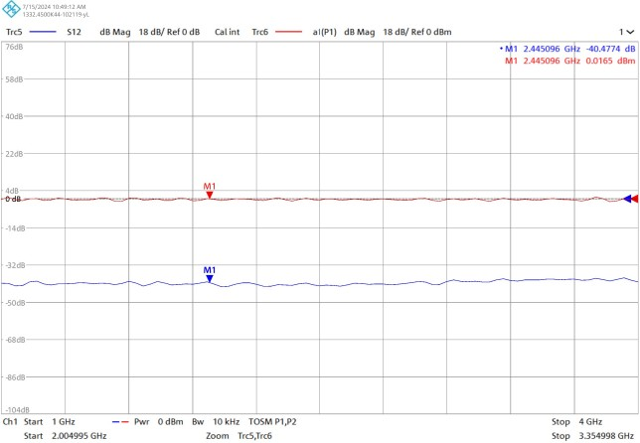

Fig 5.2.1 VSWR using direction coupler

Fig 5.2.2 VSWR using direction coupler

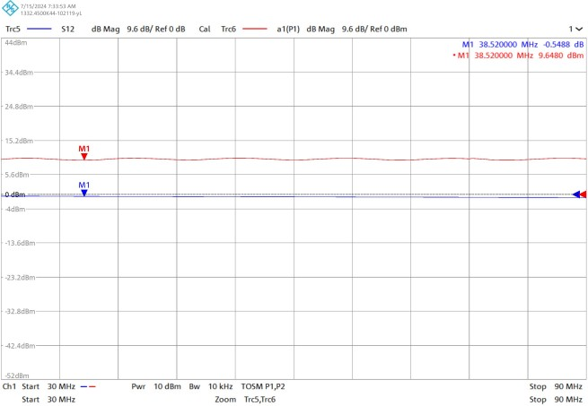

One useful way to evaluate antenna impedance matching is to measure VSWR using a directional coupler. If you plan to use a directional coupler to measure VSWR, here’s how to analyze your coupler design and the measurement results for your system.

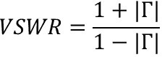

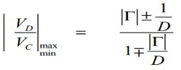

With this equation, you can plug in the value of D and the measured voltages, and finally solve the above equation for the reflection coefficient. You can then use the result to calculate VSWR.

* 1. **VSWR of Transmitting Antennas using VNA:**

VSWR Stands for ‘Voltage Standing Wave Ratio’ and is used in EMC to specify the effect of mismatch presented to a test system signal.At microwave frequencies slotted lines became a way of accurately determining the ratio of the maximum voltage to the minimum voltage (the VSWR, symbol ‘s’), and because of the simplicity of measurement and the easy math associated with it, VSWR became an everyday parameter. As the name suggests, a slotted line is a length of waveguide with a slot along the top. A probe is moved along the slot and a detector gives the voltage at any point on the line. Once you have obtained the two extremes of voltage you can determine the ratio of the two. Once you have this ratio it is easy to calculate the reflected power coefficient, symbol rho. The reflected power coefficient is the amount of power reflected back compared to the incident power.

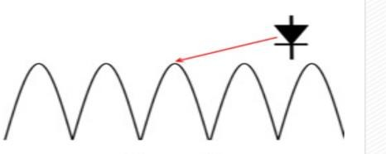

5.3.1 VSWR of transmitting antennas

* 1. **SMITH CHART**

A Smith chart is a circular plot with a lot of interlaced circles on it. When used correctly, matching impedances, with apparent complicated structures, can be made without any computation. The only effort required is the reading and following of values along the circles. The Smith chart is a polar plot of the complex reflection coefficient (also called gamma and symbolized by Γ). Or, it is defined mathematically as the 1-port scattering parameter s or s11.

Fig 5.4.1 Smith Chart

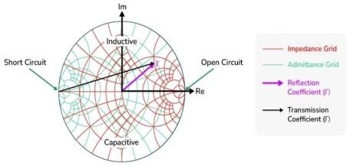

A Smith chart is developed by examining the load where the impedance must be matched. Instead of considering its impedance directly, you express its reflection coefficient ΓL, which is used to characterize a load (such as admittance, gain, and transconductance). The ΓL is more useful when dealing with RF frequencies. We know the reflection coefficient is defined as the ratio between the reflected voltage wave and the incident voltage wave:

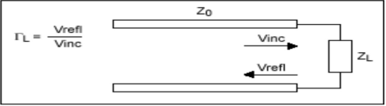

5.4.2 Transmission medium for s parameters

The amount of reflected signal from the load is dependent on the degree of mismatch between the source impedance and the load impedance. Its expression has been defined as follows:

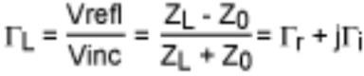

* + 1. **Components of Smith Chart:**

While understanding the Smith chart, we need to understand its components. There are various components depending on the type of Smith Chart which is as follows:

**5.4.1.1 Constant R Circles:**

The figure given above represents the constant resistance circle. The horizontal line represents the resistance axis. It is used to represent the complex impedances of the resistive part of the circuit. The centre has the normalized resistance R=1. A circle (red color) tangent to the right side of the chart which passes through the prime center represents the constant normalized resistance circle with the constant resistance of 1. A similar circle (pink color) which passes through the resistance axis at R=0.2 represents the normalized resistance of 0.2 at every point on that circle.

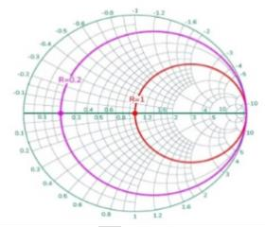

Fig 5.4.1.1.1 const R circles

**5.4.1.2 Constant X Circles**

It is known as the constant reactance circle. The reactance axis lies across the circumference of the Smith Chart. The figure given below represents the constant reactance circle.

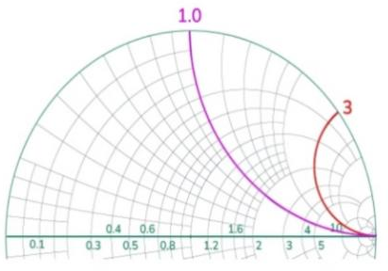

Fig 5.4.1.2.1 constant X circles

Every point along the curve (either pink or red) has the same value of reactance or imaginary part. The points lying on the pink curve have the normalized reactance of 1.0 while the points lying on the red curve have the normalized reactance of 3.0. The upper half of the Smith Chart have the positive reactance value (inductive) while the lower half of the Smith chart have the negative reactance value (capacitive).

5.4.1.3 **Advantages of Smith Chart:**

* Smith chart helps find the complex impedance and reflection coefficients. It makes the analysis of RF circuits easier.
* It helps in finding the matching impedance of the network which helps in the maximum transfer of the power.
* The reflection coefficients can be easily found with the help of Smith Charts. It helps in analyzing and visualizing the impedance mismatches. This helps prevent the signal reflections.
* With the help of the Smith Chart, we can find the admittance of the circuit easily. It provides additional information about the circuit which enhances the flexibility in the circuit design.
  + - 1. **Applications of Smith Charts:**
* Transmission Line Analysis: Smith charts help in understanding and correcting issues in transmission lines, such as impedance mismatches and signal reflections, critical in high- frequency applications.
* Antenna Design: Engineers use Smith charts to design and tune antennas for optimal performance by matching the antenna’s impedance to the transmission line’s impedance.
* Filter Design: In the field of microwave and RF filter design Smith Charts play a role in attaining desired frequency response characteristics by manipulating component values and impedance transformations.
* Amplifier Design: Engineers utilize Smith charts to optimize input output matching networks of amplifiers in order to maximize gain while minimizing noise levels and distortion.

5.S-parameter Analysis: These charts find application in vector network analyzers where they display S parameters providing information on how electrical signals propagate through a system.

# 6.MIL-STD-461 CE102:

**6.1Purpose:**

This requirement is applicable from 10 kHz to 10 MHz for all power leads, including returns, which obtain power from other sources not part of the EUT.This test procedure is used to verify that electromagnetic emissions from the EUT do not exceed the specified requirements for power input leads, including returns.

# 6.2Test Equipment:

The test equipment shall be as follows:

1.Measurement receiver 2.Data recording device 3.Signal generator 4.Attenuator, 20 dB, 50 ohm 5.Oscilloscope

6.LISNs

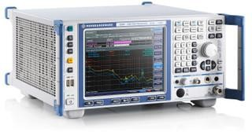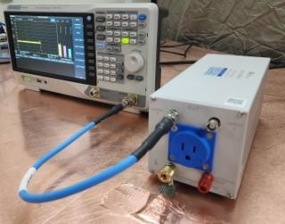

# Fig 6.2.1 A.B .Rohde & Schwarz ESRP3 EMI Test Receiver per CISPR 16-1-1

**6.3Test Procedure :**

EMI test receiver and signal/spectrum analyzer combined in one box Resolution bandwidths in line with CISPR

Weighting detectors: max. peak, min. peak, average, RMS, quasi-peak, average with meter time constant, and RMS in line with current CISPR 16-1-1 version

Very fast FFT-based time domain scan as an option,Automatic test routines

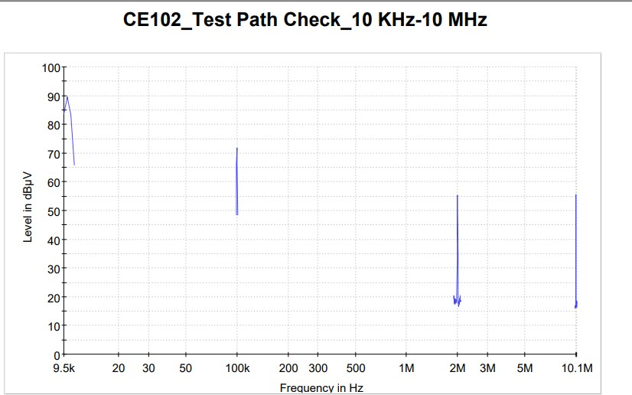

Fig 6.3.1 Test path check

# 6.4Test Setup :

The test setup shall be as follows:

Maintain a basic test setup for the EUT as shown below

# A. Calibration.

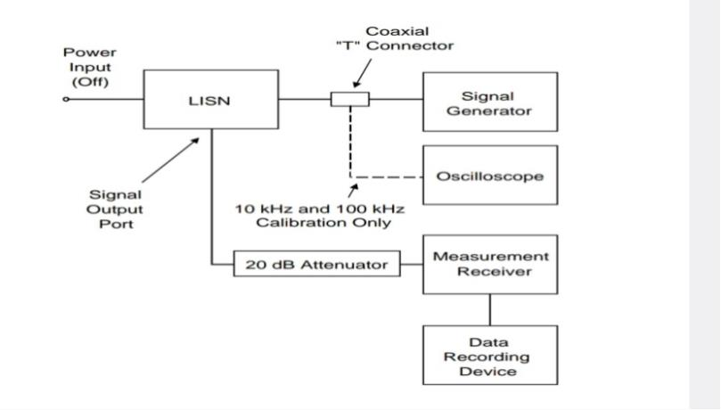

Fig 6.4.A.1 calibration setup ce102

Configure the test setup for the measurement system check and ensure that the EUT power source is turned off.

* + - Connect the measurement receiver to the 20 dB attenuator on the signal output Port of the LISN.

# B.EUT testing.

* 1. Configure the test setup for compliance testing of the EUT as shown below.
  2. Connect the measurement receiver to the 20 dB attenuator on the signal output

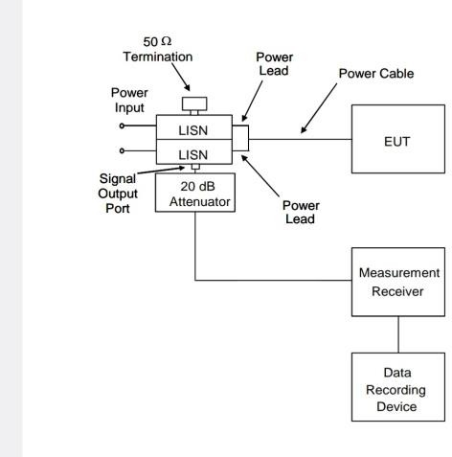

Fig 6.4.B.1 Eut testing ce102

# C.Data presentation.

Data presentation shall be as follows:

1. Continuously and automatically plot amplitude versus frequency profiles on X-Y axis outputs. Manually gathered data is not acceptable except for plot verification.
2. Display the applicable limit on each plot.
3. Provide a minimum frequency resolution of 1% or twice the measurement receiver bandwidth, whichever is less stringent, and a minimum amplitude resolution of 1 dB for each plot.
   1. d.Provide plots for both the measurement system check and measurement portions of the procedure.

Fig 6.4.C.1 Limit line ce 102

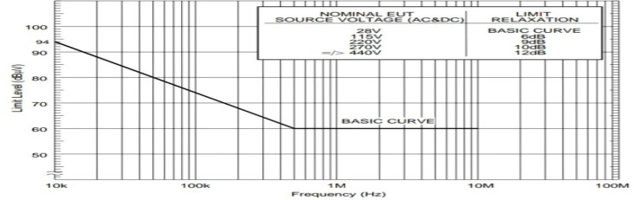

# 7 RADIATED EMISSION-RE102:

**7.1Purpose:**

RE102 is a military testing standard that is part of the MIL-STD-461 standard, which covers radiated emissions. The test measures unwanted signals emitted into the air from the device and its cables. It involves simulations of potential disturbances from magnetic sources, radio frequency sources, electrostatic discharge (ESD) sources, and electromagnetic pulse (EMP) sources.

**7.2 Requirement:**

MIL-STD 461 EMC testing standard RE102 refers to radiated emissions from equipment and subsystem enclosures, and all interconnecting cables. This standard military testing requirement does not apply to permanently mounted antennas.

This EMC MIL-461 test applies as follows:

* + - Ground 2 MHz to 18 GHz
    - Ships, surface 10 kHz to 18 GHz
    - Submarines 10 kHz to 18 GH

1. Aircraft (Army and Navy) 10 kHz to 18 GH

Fig 7.3.1 test setup with x/n calculation, when x>3

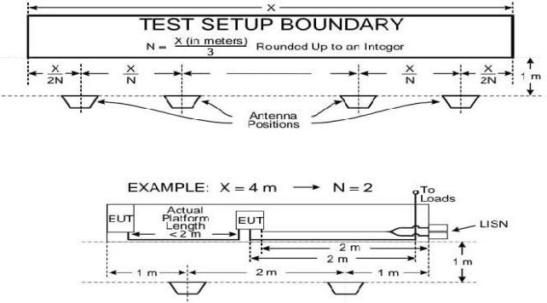

**7.3 Test equipment:**

1. Measurement receivers
2. Antennas ranging from 10 kHz to 18 GHz
3. Signal generators
4. Stub radiators
   1. **Testing Procedures:**

4

4.1.1 Ambient requirements must be verified and met. Plots are taken when required.

4.1.2 The measurement equipment is turned on and allowed sufficient time for stabilization.

4.1.3 Using the system check path, an evaluation of the overall measurement system from the coaxial cable end used at each antenna is performed. For rod antennas that use passive matching networks, the evaluation is performed at the centre frequency of each band. System check path verification is performed near the upper end of the affected frequency band. If readings are obtained that deviate by more than three dB, the source of the error is located and must be corrected.

4.1.4 An evaluation for each antenna to demonstrate that there is electrical continuity through the antenna is conducted. This is done by visually inspecting each antenna for damage.

4.1.5 After, each EUT is turned on and allowed sufficient time for stabilization.

Using the measurement path, the radiated emissions are finally determined from the EUT and its associated cabling. Lastly, measurements are taken for each antenna position.

1. **Radiated susceptibility-RS103:**
   1. **Purpose:**

This test procedure is used to verify the ability of the EUT and associated cabling to withstand electric fields.

* 1. **Requirement:**

The MIL-STD-461 lab testing requirement is applicable for equipment and subsystem enclosures. The EMC compliance test is also applicable to all interconnecting cables.

* + - 2 MHz to 30 MHz – Army, Navy and optional* for all others
    - 30 MHz to 18 GHz – All
    - 18 GHz to 40 GHz – Optional* for all

The EUT shall not exhibit any malfunction, degradation of performance, or deviation from specified indications, beyond the tolerances indicated in the individual equipment or subsystem specifications.

**The test equipment shall be as follows:**

* Signal generators
* Power amplifiers
* Receive antennas
  + 1 GHz to 10 GHz, double ridge horns
  + 10 GHz to 40 GHz, other antennas as approved by the procuring activity
* Transmit antennas
* Electric field sensors (physically small - electrically short)
* Measurement receiver
* Power meter
  1. **Test procedure:**
     + First, the measurement equipment and EUT is turned on and allowed ample time for stabilization.
     + After, the test area is assessed for potential RF hazards. The testing engineers take necessary precautions to assure the safety of all personnel.
     + Subsequently, the EUT test is performed. This is done over the required frequency ranges. The transmit antenna must be vertically polarized. The signal source is set to 1 kHz pulse modulation and 50% duty cycle.
     + An electric field is established at the start frequency. It is gradually increased until it reaches the applicable limit. The required frequency ranges are scanned. These must be in accordance with specified rates and durations.
     + If susceptibility is noted, the threshold must be determined. These steps are repeated above 30 MHz with the transmit antenna horizontally polarized. The test is also repeated for each transmitted antenna position.
  2. **Test setup**

Fig 8.4.1 Test setup RS 103

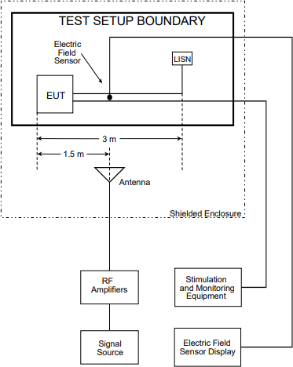

# 9.CONCLUSION:

This internship has been an extraordinary chapter in my professional journey, one that has provided me with not merely knowledge but a deeply transformative experience that will indelibly influence the trajectory of my future research work and career choices. Within the dynamic and forward-thinking environment of the Vehicle Communication Division, I was afforded the unparalleled privilege of collaborating with some of the most accomplished and dedicated professionals in the field. Their magnanimity in sharing their extensive expertise, coupled with their unwavering guidance, has been instrumental in refining our understanding and approach to intricate technical challenges.

Each day presented me with new and thought-provoking lessons, compelling me to broaden my technical horizons and foster a spirit of creative problem-solving, while concurrently emphasizing the paramount importance of teamwork, collaboration, and the relentless pursuit of excellence. The mentorship we received transcended the mere transmission of skills; it instilled within me a profound appreciation for the intrinsic value of intellectual curiosity, the transformative power of innovation, and the critical importance of perpetual learning in the quest for success.

The camaraderie and sense of belonging in the Vehicle communications division that permeated our experience here imbued every challenge with a sense of purpose and rendered every achievement all the more significant. It is with the deepest sense of gratitude that I reflect on the extraordinary opportunities to learn that were provided to me.

# 10.. REFERENCES:

1. MIL-STD-461 Standard Document.
2. [https://www.stqc.gov.in.](https://www.stqc.gov.in/emiemc-testing)
3. [Technical papers and case studies from DRDO publications.](https://www.stqc.gov.in/emiemc-testing)
4. [https://www.sciencedirect.com/](https://www.stqc.gov.in/emiemc-testing)
5. <https://www.com-power.com/blog/why-emi-emc-testing-necessary#:~:text=The%20purpose%20of%20these%20tests%20is%20to%20ensure%20that%20any,within%20its%20expected%20operating%20environment>

6. https://github.com/Biancaa-R/Antenna_optimization-and-vna-scpi_commands

APPENDIX: [6]

1)Directivity calculation:

% Create a uniform linear array

lambda=0.3;

elementSpacing = 0.5*lambda;

array = phased.ULA('NumElements',8,'ElementSpacing',elementSpacing);

% Define frequency and angle

fc = 1e9; % 1 GHz

angle = [-180:1:180];

D=zeros(1,length(angle));

% Calculate directivity

for i =1:length(angle)

D(i) = directivity(array, fc, angle(i));

end

% Plot directivity

polarplot(deg2rad(angle), db(D))

* 1. Efficiency on metal type:

% Define the frequency for analysis

frequency = 1.5e9; % 1.5 GHz

% Define the metals to be used

metals1 = {'Copper', 'Silver', 'Gold', 'Steel','Aluminium'}; % Removed 'Aluminum' due to potential unsupported error

% Initialize array to store efficiency values

efficiencies = zeros(1, length(metals1));

% Create a figure for plotting

figure;

hold on;

% Loop through each metal type

for x = 1:length(metals1)

metalType = metals1{x}; % Correctly access cell array element

% Create the microstrip patch antenna element

helement = patchMicrostrip;

% Set the conductor based on predefined options

switch metalType

case 'Copper'

helement.Conductor = metal('Copper'); % Set the conductor to Copper

case 'Silver'

helement.Conductor = metal('Silver'); % Set the conductor to Silver

case 'Gold'

helement.Conductor = metal('Gold'); % Set the conductor to Gold

case 'Steel'

helement.Conductor = metal('Steel'); % Set the conductor to Steel

case 'Aluminium'

helement.Conductor = metal('Aluminium'); % Set the conductor to Steel

otherwise

error('Unsupported metal type: %s', metalType);

end

helement.Length = 0.01; % Length of the patch (10 mm)

helement.Width = 0.01; % Width of the patch (10 mm)

helement.FeedOffset = [0, 0]; % Center feed for simplicity, adjust if needed

% Define the linear array using the patch element

harray = linearArray;

harray.Element = helement;

% Calculate efficiency

E = efficiency(harray, frequency);

% Store efficiency values

efficiencies(x) = E;

end

% Plot efficiencies

stem(1:length(metals1), efficiencies, 'b','filled');

xticks(1:length(metals1));

xticklabels(metals1);

xlabel('Metal Type');

ylabel('Efficiency');

title('Efficiency of Microstrip Patch Antenna for Different Metals');

grid on;

hold off;

% Display efficiencies

disp('Efficiency values for different metals:');

for x = 1:length(metals1)

fprintf('%s: %.4f\n', metals1{x}, efficiencies(x));

end

%therefore copper has highest efficiency:

% Define the microstrip patch antenna element

helement = patchMicrostrip;

helement.Conductor = metal('Copper');

helement.Length = 0.01; % 10 mm

helement.Width = 0.01; % 10 mm

% Define the linear array using the patch element

harray = linearArray;

harray.Element = helement;

% Calculate the efficiency at 1.5 GHz

frequency = 1.5e9; % 1.5 GHz

E = efficiency(harray, frequency);

disp(E);

* 1. Conversion of voltage from v to dBm, dBuV

1. %dbuv= 20*log10(v/uv)
2. % Generate random data for x
3. x = (10e-3:-10e-6:10e-6);
4. figure;
5. plot(x);
6. title("voltage")
7. for i=1:length(x)
8. x(i)=20*log10(x(i)/10e-6);
9. end
10. % Create a scatter plot
11. figure;
12. plot(x);
13. hold on;
14. hold off;
15. title('dB mic V');
16. xlabel('X-axis');
17. ylabel('Y-axis');
18. % Convert to dBm
19. for i = 1:length(x)
20. x1(i) = x(i) - 10*log10(50) + 90;
21. end
22. figure;
23. plot(x1, 'b');
24. hold on;
25. hold off;
26. title('dBm');
27. xlabel('X-axis');
28. ylabel('Y-axis');

4) Antenna design and gain plot:

% Define the microstrip patch antenna element

p = patchMicrostrip;

p.Height = 0.01; % Set the height of the substrate

% Plot the impedance over a range of frequencies

figure;

impedance(p, (5e8: 10e6 : 2e9)); % Frequency range from 0.5 GHz to 2 GHz

% Plot the current distribution at a specific frequency (1.66 GHz)

figure;

current(p, 1.66e9);

% Plot the radiation pattern at a specific frequency (1.66 GHz)

figure;

pattern(p, 1.66e9);

% Define another microstrip patch antenna element with different properties

helement = patchMicrostrip;

helement.Conductor = metal('Copper'); % Set the conductor to copper

helement.Length = 0.01; % Length of the patch (10 mm)

helement.Width = 0.01; % Width of the patch (10 mm)

% Ensure the feed location is within the patch geometry

helement.FeedOffset = [0, 0]; % Center feed for simplicity, adjust if needed

% Define the linear array using the patch element

harray = linearArray;

harray.Element = helement;

% Calculate and display the efficiency at 1.5 GHz

frequency = 1.5e9; % 1.5 GHz

E = efficiency(harray,frequency);

disp(class(helement));

disp(class(harray));

disp(E);